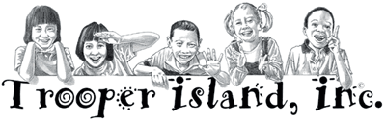

Friends and Supporters:

The 2018 Scott Lathram Memorial Golf Tournament will be Thursday, September 6th at Miller Memorial Golf Course, located in Murray, KY. This event is KSP Post 1’s fundraiser for Trooper Island. Each summer, 700-800 underprivileged children attend the free summer camp, which is operated solely from private donations.

We expect to have over 100 participants at this year’s event. With your help, this could be our biggest year ever. There are a number of ways you can lend your support to this worthy cause.
- $100- Hole Sponsor
We will place a sign with your business or company name at one of the tee boxes.
- $250- Shirt Sponsor
Have your logo on the back of tournament t-shirt, which is given to each tournament player.
- $300- Combination (Shirt and Hole) Sponsor
Sponsor a hole and have your logo on the back of the tournament t-shirt.
In addition to supporting this worthwhile cause by being a sponsor, you can also:
- Donate Gift Certificates/Prizes: used for door prizes, competition prizes, or silent auction items
- Play in the Tournament: $240 for a four person team

Checks should be made out to “Trooper Island Golf Tournament”. Donations can be picked up by a KSP Trooper (by calling 270-856-3721) or mailed to:

Kentucky State Police Post 1
c/o Trooper Island Golf Tournament
8366 Highway 45 North
Hickory, Kentucky 42051

If you have any questions or need further information please contact Trooper Jay Thomas by cellphone at 270-356-6264 or email at dennis.thomas@ky.gov Please remember all contributions to Trooper Island are tax deductible.

