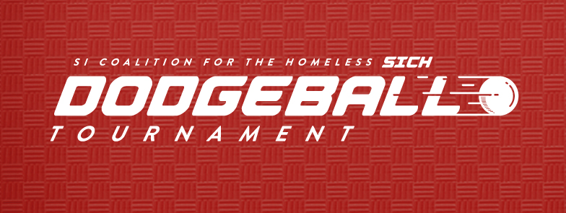

**Huge thank you to all the participants of this year’s Dodgeball Tournament. With your help we raised $2,400 to benefit the Southern Illinois Coalition for the Homeless. Thank you to the following sponsors who helped make this event possible:**

River Radio of Southern Illinois

The HUB

Architechniques, Ltd.

Aisin Electronics Illinois, LLC

Heartland Regional Medical Center

Dave Thompson Realty

Priority Groups

Thad Ellet Plumbing

Garavalia Heating and Air

Farmer’s State Bank

Adam Thompson at Graphic Justice

Tyler Young at The Print Shop

Culvers of Marion

National Guard

Subway of Marion

Jimmy Johns of Marion

Black Diamond Harley Davidson

Krispy Kreme of Marion

Regions Bank of Marion

Mid Country Bank of Marion

Cool Spoons of Marion and Carbondale

**Congratulations to The Dodge-Fathers for taking home the “Gold” in the Adult Division and The Dogs for 1st place in the Youth Division.**