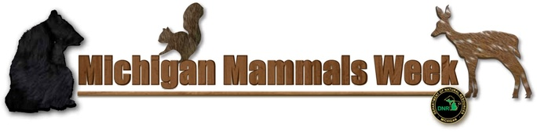
Warren Dunes State Park

Wednesday, July 12

3pm - Michigan Mammals
Campsite 83
Learn about the mammals of Warren Dunes. See skulls and skins of the common animals that live in our forest.

Thursday, July 13

3pm - Deer Me
Campsite 37
We celebrate a year with deer and learn about the behavior of these graceful animals. Why are there so many and where do they hide? How old do deer get and how can they find their way in the dark?

Friday, July 14

5pm - Mammal Tracks
Campsite 83
Warren Dunes is home to many mammals—more than you realize. But where are they? Learn to see signs of mammals in the forest and follow their tracks. You too can read the secret forest signs

Saturday, July 15

5pm - Beautiful, Brilliant, Bats Bats Bats
Campsite 83
Learn the myths and facts about Michigan bats. Trade your worry for wonder at these beautiful creatures.

