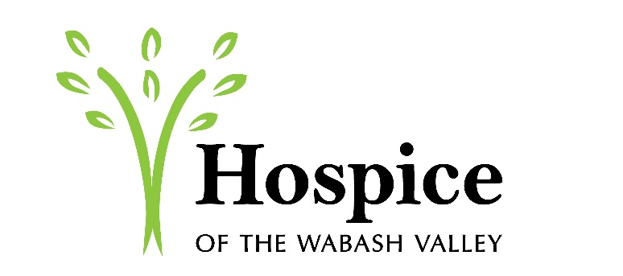

31st Annual Tulip Fundraiser

Hospice of the Wabash Valley is now offering pre-order for our 31st annual Tulip Fundraiser.

If you get your order in by Monday, April 16th you will be able to have your bouquets delivered. You can order by calling 812-234-2515 or you can visit myhospicevna.org to download an order form. Delivery is available within city limits of Terre Haute, Brazil, Clinton and Sullivan.

If you do not get your order in by the 16th you can still order and schedule for pickup. We will also be set up on the day of delivery, April 25th, for last minute purchases. We will have purchase sites at the VNA and Hospice office, Baesler’s Terre Haute, Baesler’s Sullivan, Crossroads Café, Union Hospital and The Tulip Company.

Hospice of the Wabash Valley is the only not-for-profit Hospice in the Wabash Valley. Funds raised will go towards patients that are unable to afford end of life services and care

Allison Lark
Community Liaison
VNA Homecare & Hospice of the Wabash Valley
812-239-4764
alark@myhospicevna.org

