K-COUNTRY’s Golf Tournament
Ocala Golf Club – 3130 E. Silver Springs Blvd. Ocala, FL 34470
Friday, February 24, 2017
Presented By:
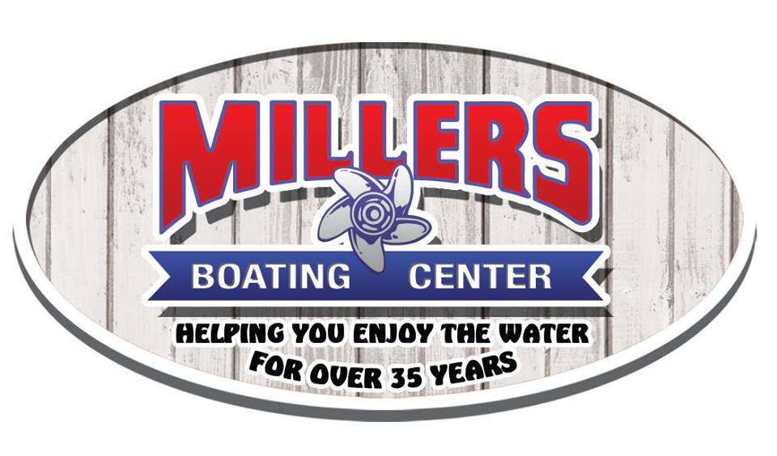
Four person teams
(Space is limited)
$75 per golfer includes
green fee, cart fee, range balls,
deluxe cookout before tournament and appetizers during award ceremony.
Tee off is at 12:00 pm – shotgun start
Hole-IN-One brought to you by Millers Boating Center.
Prizes and raffle to follow tournament.
Help raise money for First Tee of Ocala!
Name of Players Handicap email/phone number
1. _____________________________________________________________________________________________________
2. _____________________________________________________________________________________________________
3. _____________________________________________________________________________________________________
4. _____________________________________________________________________________________________________
Payment: Attn: Golf Tournament
Because space is limited, We will confirm your team, once registration form and payment have been received.
Check payable to: K COUNTRY. Mail to 3602 NE 20th Pl. Ocala, FL 34470
Or
Credit card application: Fax number 352-622-7822 or holly@windwogksales.com
