COIN DRIVE for Playground
AKA: Coins for Keeney
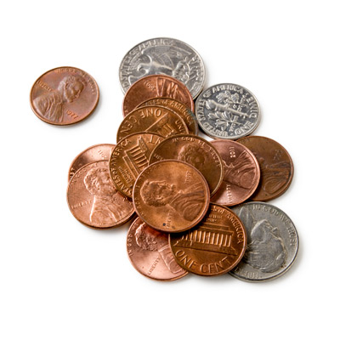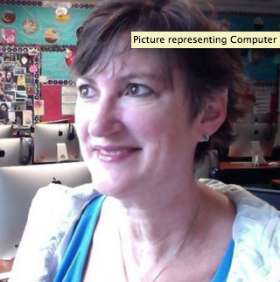
We are collecting coins (or dollars, Visa’s, and checks).
Please send your change to school. All donations/sponsorships will be tallied toward the goal of Sliming:………… MRS. KEENEY

If we reach $10,000 before 2016, she agrees to be SLIMED when we return from Christmas Break!!!

All donations are Tax-deductible.
Look for creative ways you can support the playground project at http://valdezplayground.org/
OR Call Katey Connell at 831-9775.

