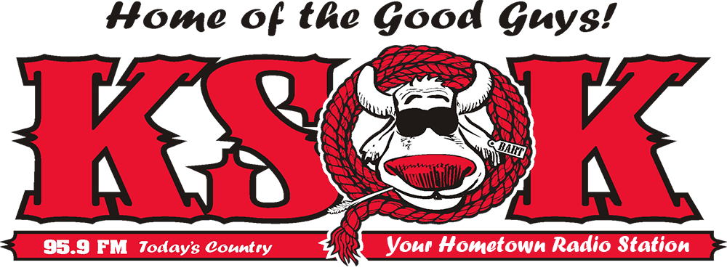
EEO PUBLIC FILE REPORT
Cowley County Broadcasting - Stations: KSOK AM & FM
PERIOD COVERED: February 1, 2017 – January 31, 2018

A: Full time positions filled: 2
B: Total number of people interviewed for full time vacancies: 22

Full-time Positions Filled By Job Title and Date Filled |  | Recruitment Source that Referred the Person Hired | Number of Person Interviewed
1. | Sales Personnel 3/27/17 | Marty Mutti Referral | 1
2. | Sales Personnel 12/1/17 | Facebook | 1

Source | Total number of Interviewees from source during period: | Full-time positions for which this source was utilized
Allaccess.com  www.allaccess.com  Opening Posted By Marty Mutti | 8 | 3
Arkansas City Traveler Newspaper  200 East 5th Street  Arkansas City, KS 67005  620-442-4200 | 4 | 1
KSOk Business Facebook | 2 | 1
KSOK Radio.com Website  Marty Mutti, General Manager  KSOK  334 East Radio Lane  Arkansas City, KS 67005  620-442-5400 | 1 | 1
KSOK Referral  Marty Mutti, General Manager  KSOK  334 East Radio Lane  Arkansas City, KS 67005  620-442-5400 | 1 | 1
Winfield Courier  201 East 9th Street  Winfield, KS 67156  620-221-1050 | 4 | 2
- ** Sources asked to be notified were notified.

D: Outreach activities during the time period:
1. Activity from Outreach Initiative Worksheet: #1

Date: March 1st, 2017
Event: Cowley First Job Fair, 300 Viking Blvd, auxiliary gym 3, Winfield, KS
Description: Quinn Holmquist attended the Cowley First Job Fair. He discussed the broadcast field and offered participants applications for possible positions at Cowley County Broadcasting.

2. Activity from Outreach Initiative Worksheet: #1

Date: March 2nd, 2017
Event: Cowley First Job Fair @ Cowley College, Arkansas City, KS
Description: Brett Coplen attended the Cowley First Job Fair. He discussed the broadcast field and offered participants applications for possible positions at Cowley County Broadcasting.

3. Activity from Outreach Initiative Worksheet: #1

Date: March 29th, 2017
Event: McConnell Air Force Base Job Fair, Wichita, KS
Description: Dustin Arthur and Brett Coplen attended the Job Fair. They talked with people leaving and/or retiring from the army about possible positions with Cowley County Broadcasting.

4. Activity from Outreach Initiative Worksheet: #4

Date: October 2nd, 2017
Description: KSOK was a National Night Out Co-sponsor for the listening area held at Paris Park in Arkansas City, Kansas. Marty Mutti, and Shane Farley talked with various people about KSOK’s role in the community and invited people to come by for a tour and fill out an application.

5. Cowley First Future Finance Winfield

Date: October 3rd, 2017
Description: Shane Farley & Dustin Arthur went to Winfield High School to help students learn how to manage their money and gain some insights into budgets, jobs and life.

6. Cowley First Career Advancement and Preparation Ark City

Date: October 4th, 2017
Description: Marty Mutti & Amanda Bowker went to Arkansas City High School to help students learn how to manage their money and gain some insights into budgets, jobs and life.

7. Activity from Outreach Initiative Worksheet: #6

Date: Ongoing
Description: Marty Mutti, Dustin Arthur, and Shane Farley conduct station tours from various groups and organizations including: Boys and Girl Scouts, Elementary – Middle – High School and College groups.

8. Activity from Outreach Initiative Worksheet: #6

Date: February 24th, 20176
Description: KSOK had a table set up at the Fury of the Plains Severe Weather presentation sponsored by the National Weather Service of Wichita and the Cowley County Emergency Management. Marty Mutti was able to discuss KSOK’s function in the covering of severe weather. They invited the attendees to come by the station and fill out an application for part or full time positions with KSOK.

9. Activity from Outreach Initiative Worksheet: #6

Dates: March 9th, 2017
Description: KSOK is a media member of the Local Emergency Planning Committee for Cowley County. In addition, there is a standing offer that if any staff member or volunteer of any of the participating groups would like to get into Broadcasting, they are invited to come to the studios and fill out an application and take a tour.

10. Activity from Outreach Initiative Worksheet: #6

Date: April 16th, 2017
Description: Cowley County Health & Safety Fair in Ark City. Marty Mutti and Pam Miller talked with people about KSOK’s roll in the community and how important communication becomes during an emergency. They had applications with them and invited people to fill them out if they have an interest in broadcasting.

11. Activity from Outreach Initiative Worksheet: #8

Date: April 7-12, 2017
Description: Marty Mutti and Amanda Bowker attended the National Association of Broadcasters show in Las Vegas. He spoke with several vendors about upcoming technology and how it could applied at KSOK.

12. Activity from Outreach Initiative Worksheet: #8

Date: June, 2017
Description: Dustin Arthur read many laws regarding legal RF exposure and how to measure that exposure. Using this data and the regulations at hand, all signage around our towers and at the larger grounds that hold them were updated to be accurate and warning of the possible dangers. Dustin reviewed the current FCC and OSHA requirements related to RF Safety at broadcast transmitter facilities in order to make employees and contractors fully aware of the potential for exposure to radiofrequency electromagnetic fields.

13. Activity from Outreach Initiative Worksheet: #9

Date: Ongoing
Description: Brett Copland is working with Dustin Arthur on acquiring skills to do web programming, and Promotions. This is outside of his normal job duties of Office support staff.

14. Partnership with Southwestern College

Date: 2017-18 Fall and spring sports
Description: KSOK has entered into a venture with SouthWestern College in Winfield to allow their students to broadcast the Southwestern College games to gain experience in media broadcasting.

