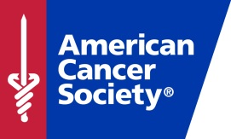
For Immediate Release 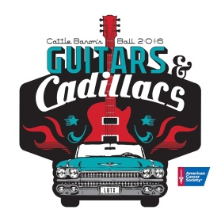
Date: July 14, 2016
Contact: Sheri Mudd, (806) 317-0800
smudd@kamc.tv

American Cancer Society’s 2016 Cattle Barons Ball
“Guitars and Cadillacs” tickets on sale
For more than three decades, the American Cancer Society’s Lubbock Cattle Baron’s Ball has raised money for cancer research and services for cancer patients. This year’s Guitars and Cadillacs event marks the 34th Cattle Baron’s Ball, scheduled for July 30th at the V-8 Ranch. Pre-party events begin at 5 p.m. at City Bank, 5219 City Bank Parkway. Transportation will be provided from City Bank to the V-8 Ranch beginning at 5:30 p.m. for those with Baron’s tickets, 6:30 p.m. for those with Wrangler’s tickets.
The event will feature entertainment Reckless Kelly and Nightowls. Grammy-nominated Reckless Kelly, an Austin, Texas based Americana/Texas Country band will headline the night. New to the ball this year, the Nightowls will both open the party and finish out the night.
Cattle Baron’s Ball offers something for everyone; enjoy a variety of tasty treats and eats Route 66 style provided by Café Venture Company. Enjoy Las Vegas-style games, bull rides, a martini and shot bar, a wine pull and more. Live and silent auctions complete the evening’s fund-raising efforts and offer one-of-a-kinds items including a hat, fiddle and bow played by Charlie Daniels, a Costa Rica vacation complete with a round of golf for four at one of the top 100 golf courses outside the United States as well as a trip for two to experience the Masters Golf Tournament as well as several other great items.
More than $6.5 million has been raised by Cattle Baron’s Ball events in Lubbock. This year’s event will raise funds for Hope Lodge and breast cancer research. Tickets range from $275 to $1100 and are available at LubbockCattleBaronsBall.org, or by calling 806.792.7128.
Signs of Hope
Signs of Hope will line the entrance to the V-8 Ranch the night of the Cattle Baron’s Ball. Signs may be purchased for $25 each in support, memory or honor of a loved one at LubbockCattleBaronsBall.org by July 22nd. Signs of Hope are a special way for anyone to honor a loved one and their battle with cancer. All signs will be available to take home by the purchase following the event on the 30th.
Truck Raffle
Reagor Dykes Auto Group generously donated the usage of a 2016 Ford F-150 Platinum to one lucky winner for a period of 36 months from the date of the drawing. Tax, title and license will be provided by Reagor Dykes Auto Group. Chance drawing tickets are on sale for $50 each. You need not be present to win.
###
