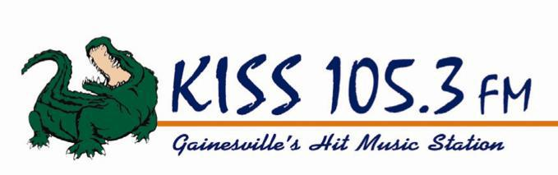

KISS 105.3 is accepting applications for a Part Time Remote Engineers.

This position includes:

- Loading Broadcast Equipment and Prizing
- Operating the Prize Wheel and Distributing Prizes to Winners
- Setting up, Keeping Clean, and Breaking Down/Cleaning up Refreshments
- Driving Station Vehicles and being Responsible for Vehicle Safety and Security
- Performing Routine Maintenance on Equipment and Storage Areas
- Serve as Back-Up for Board Operation
- Other duties assigned by Management

Excellent communication skills, writing skills, computer skills, technical skills, and public speaking required.

Clean Driving Record Required, must be over the age of 18 to drive the station vehicles.

We are an equal opportunity employer, dedicated to non-discrimination in employment on the basis of race, color, age, religion, sex, national origin, handicap, disability or marital status.

To Apply, stop by our business office at 7120 SW 24th Ave, Gainesville, FL 32607, fax your resume to 352-331-0401 or email Reception@kiss1053.com.

Douglas Gillen
Business Owner
Gillen Broadcasting Corporation
WYKS/KISS 105.3
7120 SW 24th Ave
Gainesville, FL 32607
Phone: (352) 331-2200
Fax: (352)-331-0401
Email: Reception@Kiss1053.com

