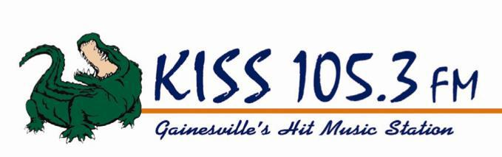

KISS 105.3 is accepting applications for a Part Time (weekends) On-Air/Board Op.

This position includes:

- Operating the board at designated times during a five hour radio show on KISS 105.3 FM.

- Work nights and weekends.

- Operating the board for live remotes on weekdays, weeknights and weekends as needed.

We are an equal opportunity employer, dedicated to non-discrimination in employment on the basis of race, color, age, religion, sex, national origin, handicap, disability or marital status.

To Apply, stop by our business office at 7120 SW 24th Ave, Gainesville, FL 32607, fax your resume to 352-331-0401 or email Reception@kiss1053.com.

Doug Gillen
Business Owner
Gillen Broadcasting Corporation
WYKS/KISS 105.3
7120 SW 24th Ave
Gainesville, FL 32607
Phone: (352) 331-2200
Fax: (352)-331-0401
Email: Reception@Kiss1053.com

