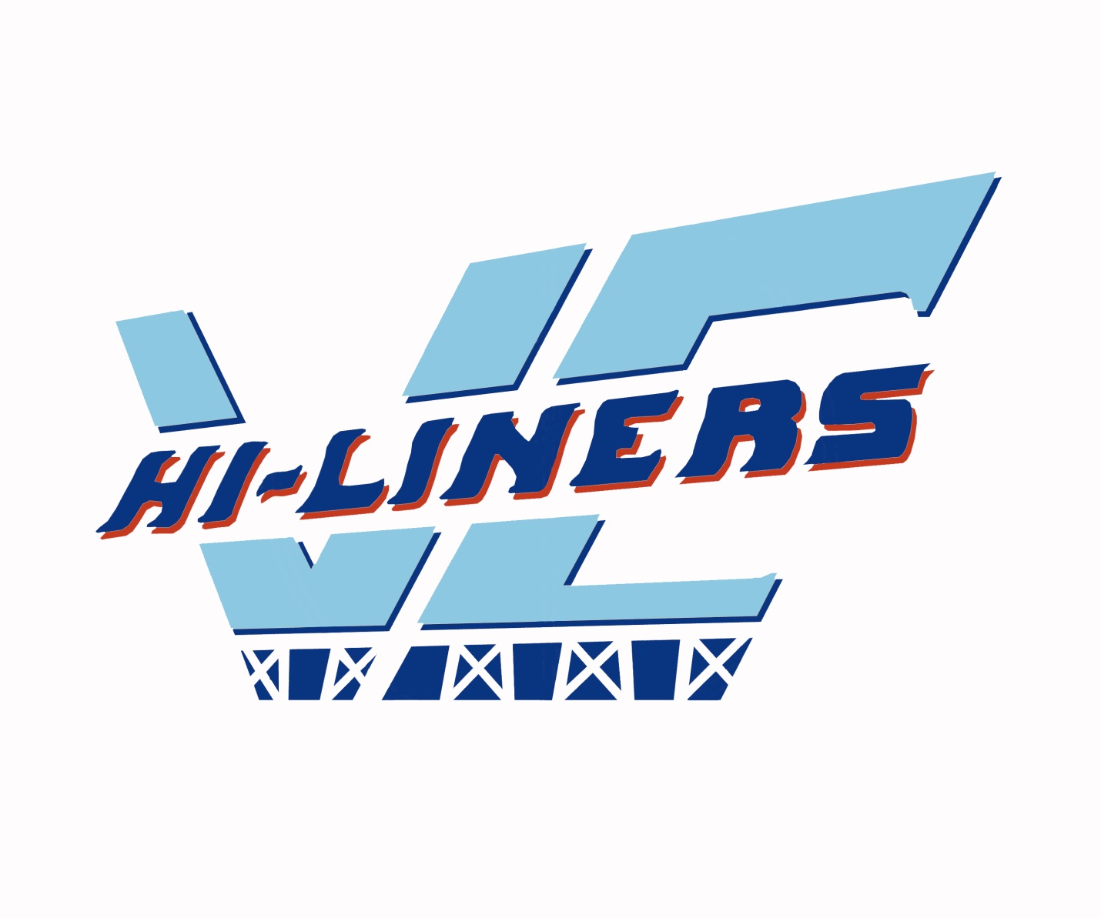
VALLEY CITY PUBLIC SCHOOLS

REGISTRATION SCHEDULE 2017-2018

MONDAY AND TUESDAY, AUGUST 14 & 15, 2017

9:00AM-1:00PM & 4:00-6:00PM

ALL REGISTRATION WILL BE IN THE HI-LINER ACTIVITY CENTER (H.A.C.)

NEW JR/SR HIGH STUDENT REGISTRATION
FRIDAY, AUGUST 11, 2017 8:30AM – 3:30PM

Grades 7-9 register in the Junior High Office

Grades 10-12 register in the Senior High Office

School Starts on
Wednesday, Aug. 23.
This is a full day of school.
Will pay for all school fees with ONE check or cash at a checkout line.

SCHOOL FEES 2017-2018

ELEMENTARY
Student Activity Ticket (Optional) $50.00
SCHOOL LUNCH PROGRAM
Junior/Senior High (20 meals)……...$60.00/$3.00 Daily
Elementary (20 meals)……………...$55.00/$2.75 Daily
Jeff/Wash Elem. Milk Break (Optional) $55.00 per year
$30.00 per sem.
Elementary Breakfast (20 meals)…..$42.00/$2.10Daily
Jr./Sr. High Breakfast (20 meals)…..$55.00/$2.75 Daily
Adult Breakfast (20 meals) ……….. $55.00/$2.75 Daily
Adult Lunch (20 meals) ……………$75.00/$3.75 Daily
NON-ATHLETIC PARTICIPATION FEES
Swing Choir $40.00
Jazz Band $40.00
Student Congress $55.00
Speech $65.00
(Maximum Participation Fee per Family $140.00)
ATHLETIC PARTICIPATION FEES
Gr. 9-12 per Sport $70.00
Gr. 7-8 per Sport $60.00
Cheerleader (Grades 7-12) $45.00
Dance Team Participation $45.00
(Maximum Participation Fee per Family $270.00)
SPORTING EVENTS ENTRANCE FEES
Students $ 4.00/game
Senior Citizens $ 5.00/game
Adults $ 6.00/game
Adult Season Ticket $75.00
JUNIOR-SENIOR HIGH SCHOOL
Student Activity Ticket (Optional) $50.00

ADDITIONAL FEES
Tech Ed - Gr. 9-12 (Semester) $30.00
Foods – Gr. 9-12 (Semester)…………..……$30.00
Art Fee – Grades 9-12 (Year) $60.00
Band Instrument Rental Fee $90.00
BUS FEES
City Busing $53.00 Month/individual child
$80.00 Month maximum per family
Reduced Fees ……... $33.00 Month/individual child
$48.00 Month/family

Daily one way pass…$2.65 (round-trip $5.25)/child
(Daily passes may be purchased at the schools)

Rural Busing
Family $235.00/Semester
(When paid in full - $425.00/Year)
Reduced Fees ……………… $140.00/Semester
(When paid in full - $235.00/Year)

All Bus Registration and Payments will take place at Registration in the H.A.C. Cash or Check please, no Credit Cards. Must register every year for busing. NEED TO BE REGISTERED BY AUG. 17, 2017 AT NOON TO RIDE THE FIRST DAY OF SCHOOL. PAYMENT DUE AT REGISTRATION.

