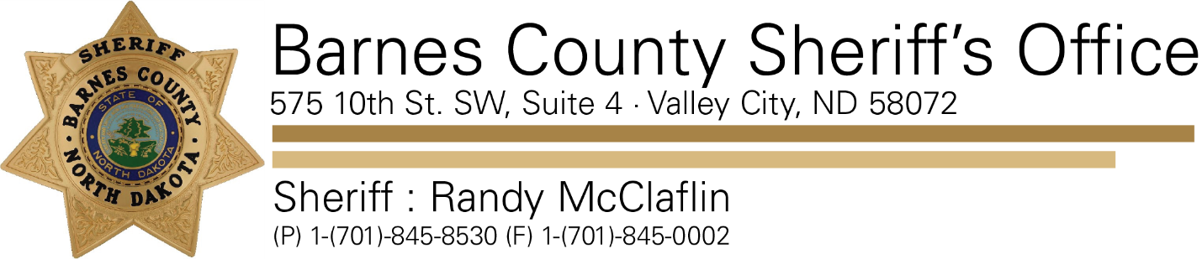

April 23, 2019

Re: Unattended Deaths

On 04/22/19 the Barnes County Sheriff’s Office responded to two separate incidents, both involving unattended deaths.

The first incident was reported around 1300PM near the Steele County/ Barnes County line. The North Dakota Bureau of Criminal Investigations (NDBCI) was contacted and asked to assist with the investigation. The NDBCI is handling this investigation.

The second incident was reported around 2017PM and occurred near a cemetery south of Sanborn, ND. The Barnes County Sheriff’s Office responded to this incident as well and is handling this investigation.

There is no threat to the public. No additional information will be released at this time.

