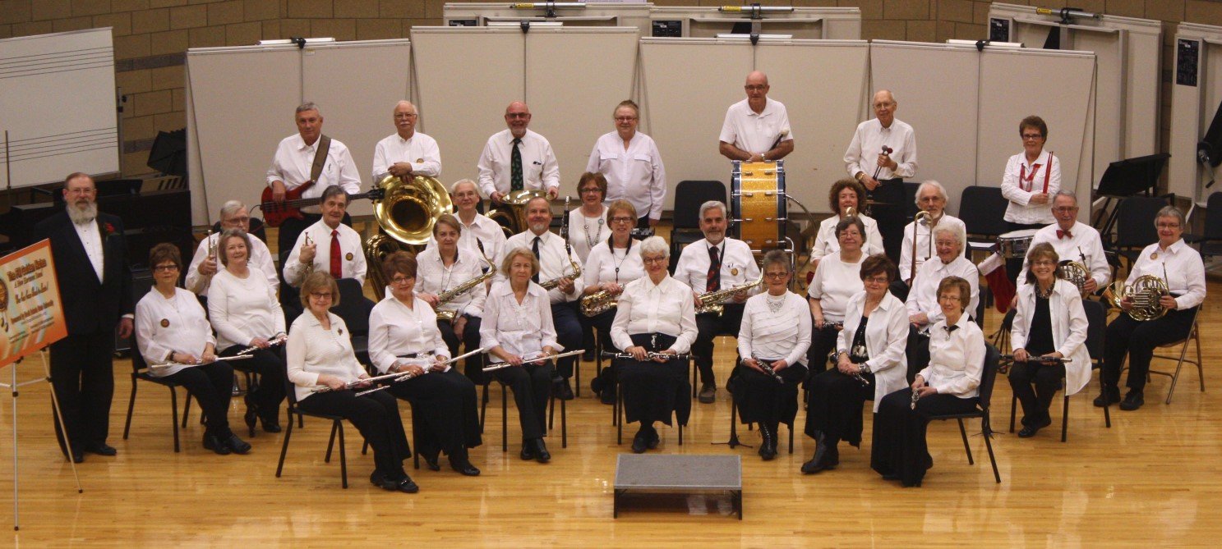
FM Golden Notes coming to Music in the City Park Bandshell June 19
Music in the City Park Bandshell on Wednesday, June 19 will feature the FM Golden Notes New Horizons Band from Fargo-Moorhead. They will begin playing at 7:15 pm. Several from the surrounding area is part of this group. Come early and enjoy tacos in a bag provided & served by Taco Johns starting at 6:45 pm. (Due to inclement weather, the program will be held at the Foss Music Building on the VCSU Campus, College St. SW)
The New Horizons Band in the Fargo- Moorhead area was generously fostered from the beginning by North Dakota State University by providing the group of older musicians a place to rehearse each week during the school year using their band practice room.
In the years that followed they added and lost members until today they number nearly 30 musicians. All of those in the band consider the band "family" to be about more than just playing music. It is also a rich social connection to others where many have formed warm friendships.
The FM Golden Notes fill a special musical niche in this community. The band motto is, "Your best is good enough."
Bring your family & lawn chairs and enjoy the evening with neighbors & friends! A freewill offering is taken each night for the continued support of the City Park Bandshell.
Music in the Park is sponsored by the Valley City Parks & Recreation District, Bridges Arts Council, KOVC, Myron Sommerfeld family, CVB Cass County Electric & BEK .
Questions, call Diane at 701-845-3294, or email: vcpr@vcparks.com.

