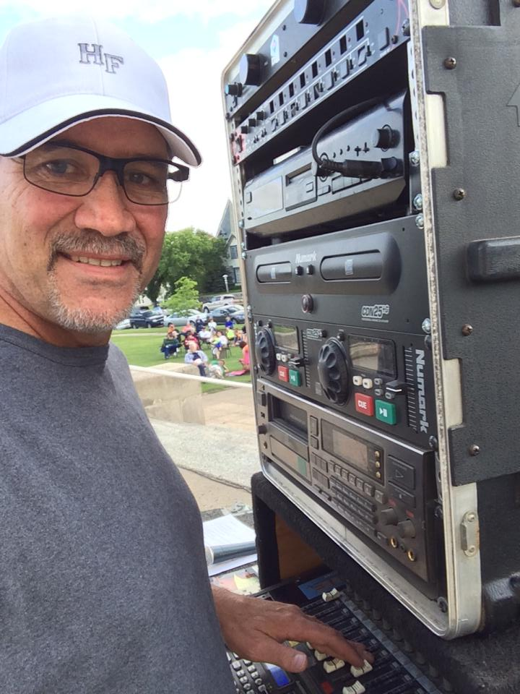

***Music in the Park features Paul Leier Karoake, July 10***

Paul Leier from Big Hammer Music Entertainment will be entertaining at the weekly Music at the City Park Bandshell on Wednesday, July 10th starting at 6 pm with Karaoke. This is open to everyone who wants to participate or just come on out & listen to the talent or join in. The evening promises to be full of talent and lots of fun! Note the time change, starting at 6 with music till 8:30 pm. There will be a variety of activities going on in City Park starting at 5:00 pm. All ages are welcome! If the weather doe not permit, everything will be cancelled in the park.

Paul Leier has owned and operated Big Hammer Music Entertainment for over 20 years now. Most of those years have been in and around the Valley City area, while the first eight years were in the Twin Cities.

Big Hammer Music is a Mobile DJ, Karaoke, and live music system. Paul has had the opportunity to meet many people and make many new friends along this journey. The most recent years have been very busy with wedding receptions, college and high school dances and of course, the area that started it all.Karaoke! Paul plans on turning the business over to his sons when they get old enough so Big Hammer Music will be around for some time. Thanks to everyone who has been part of making Big Hammer Music what it is today!

Come out early & enjoy some free popcorn…. Bring your family & lawn chairs and enjoy the evening with neighbors & friends! A freewill offering is taken each night for the continued support of the City Park Bandshell.

Music in the Park is sponsored by the Valley City Parks & Recreation District, Bridges Arts Council, KOVC, Myron Sommerfeld family, CVB Cass County Electric & BEK .

Questions, call Diane at 701-845-3294, or email: [vcpr@vcparks.com](mailto:vcpr@vcparks.com).