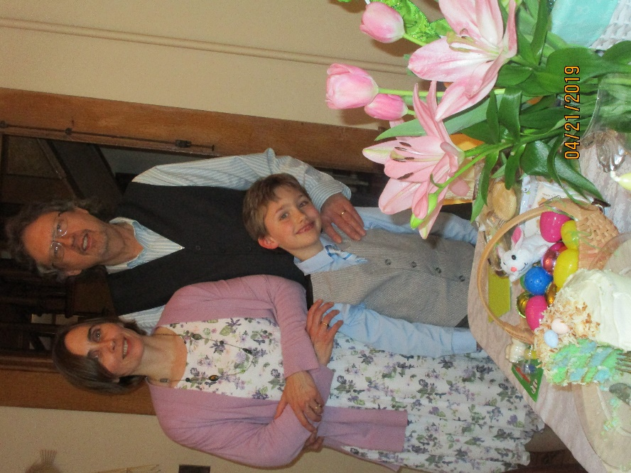

***Music at the Bandshell features***

***“Oakland Grove”, August 7***

A family group from Valley City called “Oakland Grove” will be sharing a variety of music starting at 7:15 p.m. on Wednesday, August 7th at the City Park Bandshell. Come early & enjoy ice cream floats provided by the Bridges Arts Council.

“Oakland Grove” is a Mother-Father-and-Son trio from Valley City that plays a wide variety of Rock, Country, Blues, Contemporary, and Rock’n’Roll, reflecting seven decades of popular music. The youngest member of the band, John Oakland, is 7 years old and will be in third grade at St. Catherine’s school this Fall. John has been playing drums for less than a year but has a natural sense of rhythm and a love of music, both of which help him perform well despite his limited experience. John’s favorite band is the Beatles, and his biggest musical influences are his parents. When not playing drums, he passionately enjoys trains, Hot Wheels, Legos, baseball, and reading.

Keyboardist Maggie (Gassmann) Oakland was born in Valley City and raised on a farm nearby, where four generations carried on the homestead farming tradition. The remaining fourth generation Gassmann farmer is her uncle James. In high school, Maggie marched in Bob Bowen’s Hi-Liner band. She is a Licensed Professional Clinical Counselor (LPCC) with South Central Human Service Center, serving the people of Valley City through a Valley City satellite office, and a professional guardian with Lighthouse Associates.

Maggie and Oakland Grove guitarist, Dave Oakland, met playing music 20 years ago and married in 2006. They played together in the band FIRE in venues across Eastern North Dakota and Northwestern Minnesota for 7 years until John was born in 2011. Dave is originally from Sarles, ND, and started playing professionally at age 12 with his high school bands the Squires and the Honest Truth. Since that time, Dave has played across the upper Midwest in groups including Lone Tree, Clockwork, Deliverance, and FIRE, continuing to perform with the latter on a limited basis. As well as a career musician, Dave was an electronics technician in Grand Forks, ND for 25 years.

Bring your family & lawn chairs and enjoy the evening with neighbors & friends! A freewill offering is taken each night for the continued support of the City Park Bandshell. *(Due to inclement weather, the program will be held at the Vault located on Central Ave. N.)*

Music in the Park is sponsored by the Valley City Parks & Recreation District, Bridges Arts Council, KOVC, Myron Sommerfeld family, CVB, Cass County Electric & BEK .Questions, call Diane at 701-845-3294, or email: [vcpr@vcparks.com](mailto:vcpr@vcparks.com).