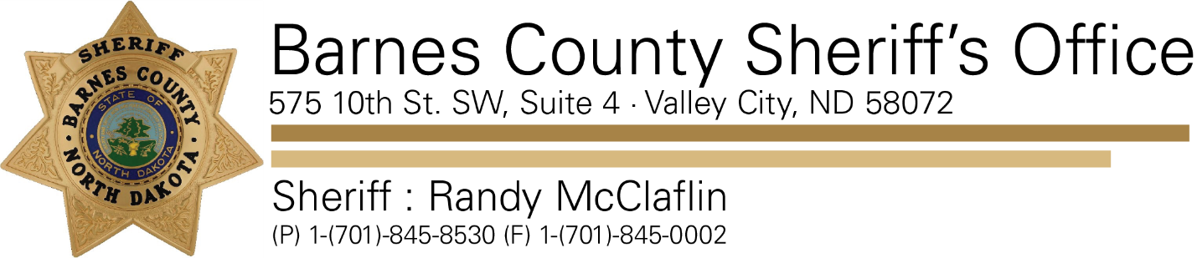

November 1, 2019

Re: Gunshot Wound

In the early morning hours of 11/01/2019 the Barnes County Sheriff’s Office responded to a 19-year-old female who had received a non-life-threatening gunshot wound.  This incident occurred in the Fingal area and the female was brought to Mercy Hospital by friends and family.  This incident is still under investigation by the Barnes County Sheriff’s Office.  An arrest was made at the residence however this arrest is not related to the shooting.