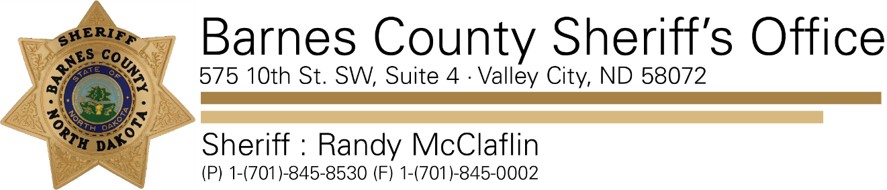

On 11/08/2019 the North Dakota Parole and Probation, Barnes County Sheriff’s Office and Valley City Police Department conducted a search of a residence in the 100 block of 6th Street North West in Valley City.

A variety of narcotics, narcotic paraphernalia along with two firearms were located and seized from the residence. Two individuals were taken into custody and criminal charges are pending. This incident is currently under investigation so if you have any additional information please contact the Barnes County Sheriff’s Office.

Attention was drawn to the residence through the anonymous Barnes County Tip411 program. Sheriff McClaflin would like to thank the public for their vigilance and assistance in this and other matters.