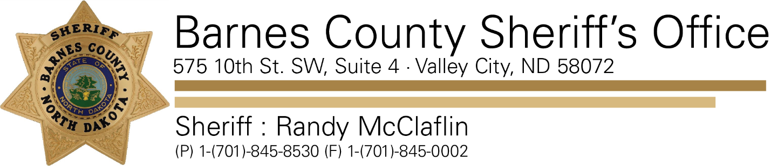

December 19, 2019

Re: Public Notification

The Barnes County Sheriff’s Office is notifying the public that a registered sex offender is living at 10448 15th St SE, Dazey, ND.

Michael Allan Nelson is listed as High-Risk offender; which was assigned by the ND Risk Level Committee of the ND Attorney General’s Office. He is required to register for his lifetime.

Nelson was born in 1989, is a white male, 5’09”, 185 lbs. blue eyes, blond hair.

When Nelson was 19 years old, he was drinking with a 14-year old girl, and then took her into a bedroom and had intercourse with her. The two had been dating before the incident. Convicted on 12/16/2009 in Barnes County District Court of Corruption of a Minor-A Misdemeanor.

For further information on sex offenders is available on the ND Attorney General’s website at [www.sexoffender.nd.gov](http://www.sexoffender.nd.gov)

