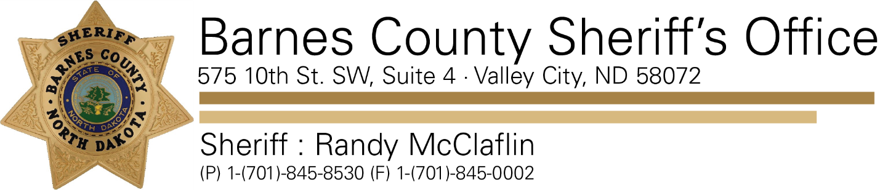

December 19, 2019

Re: Public Notification

The Barnes County Sheriff’s Office is notifying the public that a registered sex offender is living at 3523 Webster Subdivision, Valley City, ND 58072.

Justin Gibson does not have a risk level assigned with the State of North Dakota at this time.

Gibson was born in 1996, is a white male, 5’10”, 200 lbs. hazel eyes, blond hair.

Gibson plead guilty to Corruption of Minor-Victim over 15-Defendant over 22 or older-C Felony; deemed a Misdemeanor; Contributing to the deprivation or delinquency of a minor-A Misdemeanor; in Barnes County District Court on December 18, 2019.

When Gibson was 23 years of age; he had sexual intercourse with a 17-year-old female on 4 occasions, he also provided victim with a beer at a party.

For further information on sex offenders is available on the ND Attorney General’s website at [www.sexoffender.nd.gov](http://www.sexoffender.nd.gov)

