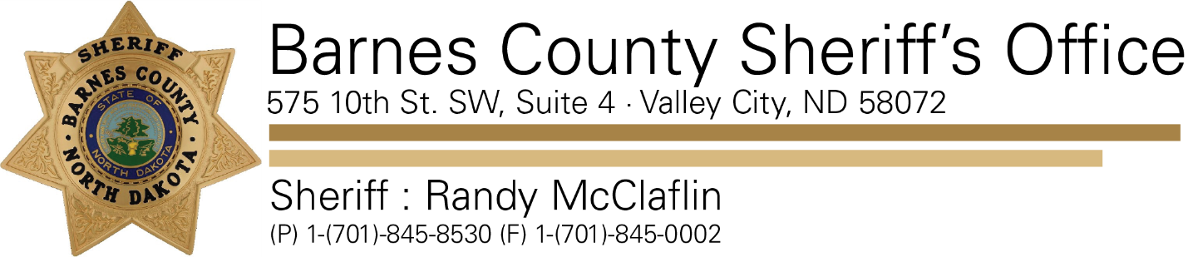

April 22, 2020

Re: Pursuit

On April 18, 2020 at 8:32 p.m. the Barnes County Sheriff’s Office Attempted to stop Corey Schneider 41, Dazey, ND for a traffic violation. When Schneider failed to stop for the deputy a pursuit ensued. The deputy attempted to stop Schneider on Hwy 1 near mile marker 98 in Barnes County. Schneider continued to flee into Griggs Co. until eventually becoming stuck in a water filled ditch. Schneider was taken in to custody without further incident. Schneider was charged in Barnes County District Court with: Reckless Driving-B Misd., Fleeing a Peace Officer-A Misd., Criminal Mischief-A Misd., Unlawful Possession of a Controlled Substance-B Misd., Unlawful Possession of Drug Paraphernalia-Infraction, Failure to Display Number Plates-Non Moving Violation, Driving Without Liability Insurance-Moving Violation.

Assisting Agencies: ND Highway Patrol, Grigg Co. Sheriff’s Office

