**BRAVE Like BRIGGS**

**T-SHIRT FUNDRAISER For BRIGGS LEE**

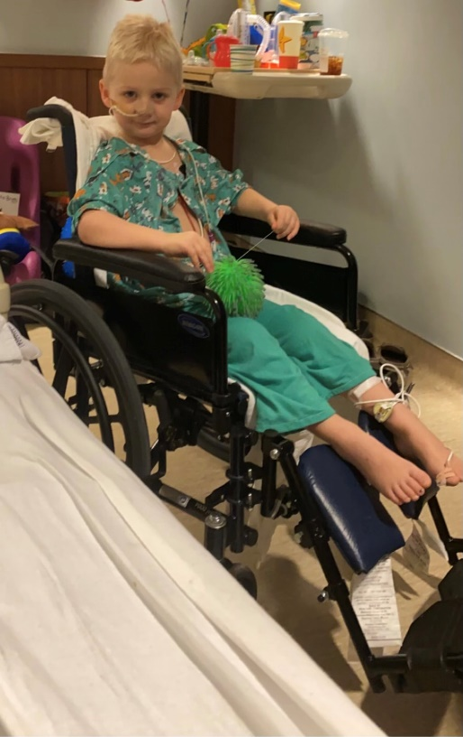Briggs Lee is the 3 year old son of Tyler and Dakotah Lee and the little brother to Emmy, Addy, and Rhett. Briggs lives with his family near LaMoure. He was recently hospitalized for 10 days and diagnosed with Miller Fisher Syndrome (MFS), which is an autoimmune disease in which the immune system attacks the nerves and is a variant of Guillain-Barré Syndrome. MFS is rare, affecting one to two people per million each year. It comes with abnormal muscle coordination, paralysis of the eye muscles, neurological episodes, absence of the tendon reflexes, muscle weakness, and respiratory failure.  
Briggs is home now, but still dealing with the effects of the symptoms of the disease. He has an NG feeding tube to help him get proper nutrition until he relearns how to eat and swallow safely. He also has a wheelchair to help him get around because of his difficulty with standing and walking. He also has issues with finger dexterity. The Lee family is traveling to Fargo a couple times a week for specialty therapies to help Briggs get back to normal life as quickly as possible!

Friends of the Lee family have put together a fundraiser to help them offset costs incurred during this difficult time. $15 of each shirt goes directly to the family. You can order online at <https://gsteesmore.com/collections/brave-like-briggs> or by returning this form to the LaMoure, Litchville, or Marion Schools or mail to: Kelli Just 9225 71st St SE Berlin, ND 58415. Checks can be written out Gs Tees.

**NAME: ___________________________________________**

**PHONE NUMBER: ________________________________**

|  |  |  |  |
| --- | --- | --- | --- |
| Size | Quantity to Order | Price Each | Total Due |
| Extra Small |  | 25.00 |  |
| Small |  | 25.00 |  |
| Medium |  | 25.00 |  |
| Large |  | 25.00 |  |
| Extra Large |  | 25.00 |  |
| 2XL |  | 25.00 |  |
| 3XL |  | 28.00 |  |
| 4XL |  | 28.00 |  |
| Youth XS |  | 25.00 |  |
| Youth Small |  | 25.00 |  |
| Youth Medium |  | 25.00 |  |
| Youth Large |  | 25.00 |  |
| Youth XL |  | 25.00 |  |
|  |  | Total Due: |  |

**Thank you for your order! Your support is greatly appreciated!**