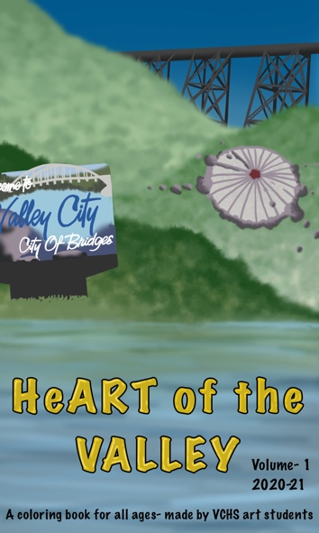
The HeArt of the Valley
Coloring Book
+ $10 Shipping Fee *only if mailing
Total:
Thank you for supporting the VCHS Art Department! Follow us on Instagram @VCPSArtDept!

Phone:

City:
Name:
Address:
The HeArt of the Valley Coloring Book (VCHS Art Dept. Fundraiser)
I will pick it up at the VCHS Office from 8am to 4pm
Drop off at child’s designated school
Mail to address above
*Shipping rates apply
Child’s Name
Child’s School
Teacher
Quantity:
I would like to make an additional donation to the art department in the amount of: $____________________
Any questions? Contact Stephani Krueger at: Stephani.Krueger@k12.nd.us
Email:
Zip code:

State:
To:
VCHS Art Dept.
460 Central Ave. N
Valley City, North Dakota, 58072
Funds raised will support the VCHS Art Dept. and Art Club Program
$10.00
Please send order form and payment by April 22nd. Make checks payable to: VCHS Art Dept. and note “coloring book fundraiser” in the memo field.

This one-of-a-kind saddle folded coloring book includes 100+ unique Valley City themed pages created by VCHS art students.

