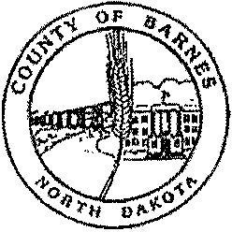

COUNTY OFFICERS

BETH DIDIER

Auditor

845-8500

DEBBIE MAGNUSON

Treasurer

845-8505

JODY PFAFF

Recorder

845-8506

TONYA DUFFY

States Attorney

845-8526

RANDY MCCLAFLIN

Sheriff

845-8530

CORRECTIONS

845-8532

DR. DAVID HOCHHALTER

Coroner

845-8776

STACIE HANSEN-LEIER

Director of Tax Equalization

845-8515

ANGELA HUNT

Veterans Service Officer

845-8511

SUE LLOYD

Emergency Manager

845-8510

KERRY JOHNSON

Highway Superintendent

845-8508

JASON THIEL

MIS Manager

845-8545

JESSICA JENRICH

Planning & Zoning

845-8188

WANDA LARSON

Social Services

845-8521

HOLLY NEUBERGER

Dispatch

845-8181

THERESA WILL

CityCounty Health District

845-8518

COUNTY COMMISSION

BARNES COUNTY

230 4TH St. NW

VALLEY CITY, NORTH DAKOTA 58072

Proclamation BURN BAN **RESCINDED**

BARNES COUNTY, NORTH DAKOTA

April 13th, 2021

WHEREAS, Barnes County, North Dakota was under abnormally dry Conditions; and

WHEREAS, the conditions have improved with the recent rain, mist and light snow fall; and

WHEREAS, the cost of response and the inordinate equipment wear is able to be managed with available resources within the county.

NOW, THEREFORE, BE IT RESOLVED, that the Board of Barnes County Commissioners hereby ***rescinds*** the burn ban that was in effect for Barnes County.

Residents are asked to monitor their controlled burns and have adequate materials needed to extinguish a fire in the event the need arises.

Residents out in the county conducting controlled burns are asked to call Barnes County Dispatch at (701) 845-8181 and let them know of the location where the controlled burn will be taking place.

The Fire Danger Rating is available at the following website: [www.nd.gov/des](http://www.nd.gov/des)

**DATED at Barnes County, North Dakota this 13th Day of April 2021.**

Dist. 1: CINDY SCHWEHR

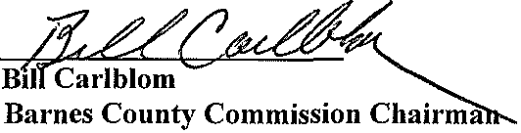

Rogers

646-6203

Dist. 2: SHAWN OLAUSON

Valley City

490-8696

Dist. 3: BILL CARLBLOM

Valley City

840-0763

Dist. 4: VICKY LOVELL

Sanborn

646-6040

Dist. 5: PETER PAULSON

Valley City

490-0524

Sue Lloyd

Barnes County Emergency Manager