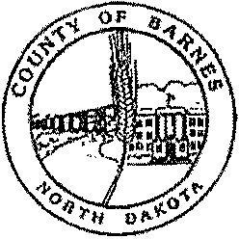
COUNTY OFFICERS
BETH DIDIER
Auditor
845-8500
DEBBIE MAGNUSON
Treasurer
845-8505
JODY PFAFF
Recorder
845-8506
TONYA DUFFY
States Attorney
845-8526
RANDY MCCLAFLIN
Sheriff
845-8530
CORRECTIONS
845-8532
DR. DAVID HOCHHALTER
Coroner
845-8776
STACIE HANSEN-LEIER
Director of Tax Equalization
845-8515
ANGELA HUNT
Veterans Service Officer
845-8511
SUE LLOYD
Emergency Manager
845-8510
KERRY JOHNSON
Highway Superintendent
845-8508
JASON THIEL
MIS Manager
845-8545
JESSICA JENRICH
Planning & Zoning
845-8188
WANDA LARSON
Social Services
845-8521
HOLLY NEUBERGER
Dispatch
845-8181
THERESA WILL
CityCounty Health District
845-8518
COUNTY COMMISSION
BARNES COUNTY
230 4TH St. NW
VALLEY CITY, NORTH DAKOTA 58072

Proclamation BURN BAN
BARNES COUNTY, NORTH DAKOTA

June 3, 2021

WHEREAS, Barnes County, North Dakota is under abnormally dry Conditions; and

WHEREAS, the impact of fires could threaten the health, well-being, and safety of citizens in Barnes County especially with forecasted weather temperatures projected to reach 95-100 degrees Fahrenheit; and

WHEREAS, the cost of response and the inordinate equipment wear may be far in excess of available county resources.

NOW, THEREFORE, BE IT RESOLVED, that the Board of Barnes County Commissioners declare a Burn Ban for Barnes County, North Dakota until June 10th, 2021 at which time it will be reviewed. This burn ban prohibits the burning of leaves, grass clippings, garbage/pits, construction debris, fallen trees, crop residue or hay land, bonfires and sloughs. Residents can use their grills and fire pits so long as there is an adult present and monitoring them and the adult ensures the fire pit and grill are completely extinguished when done using them. Campfires are allowed as long as the camp fire is in a fire ring or designated camp fire area and monitored at all times.

ANY INDIVIDUAL WHO WILLFULLY VIOLATES THIS BURN BAN IS GUILTY OF A CLASS B MISDEMEANOR, WHICH CARRIES A PENALTY OF UP TO THIRTY (30) DAYS IN JAIL AND A $1,500.00 FINE PER INCIDENT, AS WELL AS THE COST FOR FIRE SUPRESSION.

The Fire Danger Rating is available at the following website: www.nd.gov/des DATED at Barnes County, North Dakota this 3rd day of June 2021.

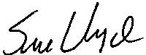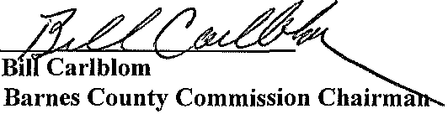Dist. 1: CINDY SCHWEHR

Rogers
646-6203
Dist. 2: SHAWN OLAUSON
Valley City
490-8696
Dist. 3: BILL CARLBLOM
Valley City
840-0763
Dist. 4: VICKY LOVELL
Sanborn
646-6040
Dist. 5: PETER PAULSON
Valley City
490-0524
Sue Lloyd
Barnes County Emergency Manager

