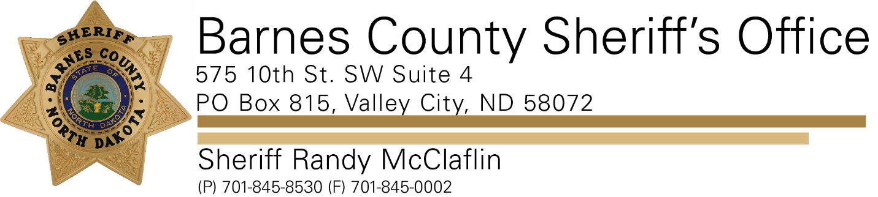

PRESS RELEASE

For Immediate Release- October 13, 20212021
Barnes County Sheriff’s Office
Contact: Sheriff Randy McClaflin

The Barnes County Sheriffs Office is asking for your assistance. We are looking for any information regarding a recent string of rural burglaries.
There have been several reports of abandoned and occupied farmsteads being burglarized throughout Barnes County. The suspects have entered buildings and homes and have removed valuables.
If you notice any suspicious activity, have confronted an unwanted person on your property, or have captured an image or video of an unwanted person on a security camera, please contact our office at 701-845-8530.

