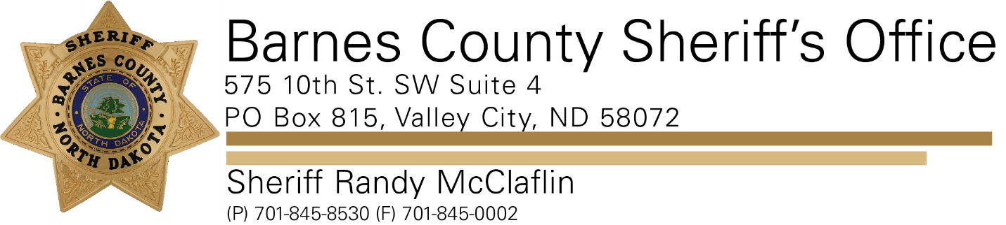

**PRESS RELEASE**

**For Immediate Release- November 16, 2021**

**Barnes County Sheriff’s Office**

**Contact: Sheriff Randy McClaflin**

A Valley City man who is facing several burglary and theft of property charges stemming from incidents reported last month in Valley City is facing more charges.

26-year-old Jeffery Lee Hoganson was arrested on November 10th after he was confronted by a Barnes County man protecting his property at a rural residence.

Hoganson is now facing criminal mischief and trespassing charges after he was allegedly caught taking property off the man's farmstead.

Hoganson is in the Barnes County Jail on a $25,000 bond.