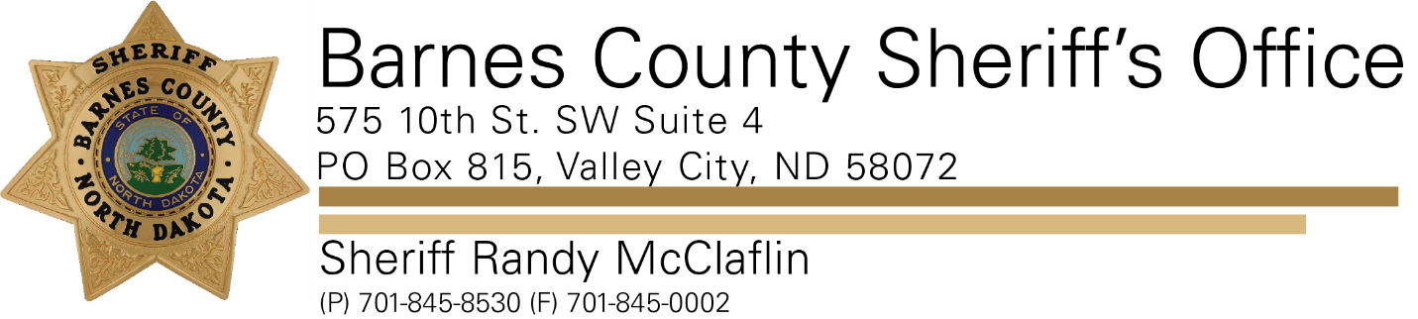

**PRESS RELEASE**

**For Immediate Release- November 23, 2021**

**Barnes County Sheriff’s Office**

**Contact: Sheriff Randy McClaflin**

**The Barnes County Sheriff's Office would like to thank the Citizens of Barnes County for information we have received regarding the recent Burglaries/Thefts that have been occurring locally.**

**From 01/01/2021 to 11/22/2021 of the 4,890 Calls for Service our office has received, 22 of those calls are related to Burglary/Breaking and Entering and 41 of them are Theft related calls.**

**For the year of 2020 during those dates, of the 3,243 Calls for Service our office had received, 17 of those were Burglary/Breaking and Entering and 46 were Theft related calls.**

**Barnes County Sheriff Randy McClaflin says sometimes it's hard to solve Burglaries/Breaking and Entering calls because a majority of them take place on abandoned properties that sometimes aren’t checked for long periods of time. Theft calls can be equally as challenging to solve because of the same reasons and items can range in value worth as little as ten dollars to hundreds of thousands of dollars. Sometimes property owners let us know about them but don't necessarily ask us to investigate them.**

**Sheriff McClaflin added that these numbers are in line with past years numbers however total Calls for Service numbers are on a rise. He would like the Citizens to know we take every one of these calls seriously and do our best to solve them. Sheriff McClaflin would also like to remind Citizens to continue to be aware of their surroundings and call our office if you notice something suspicious in your area.**