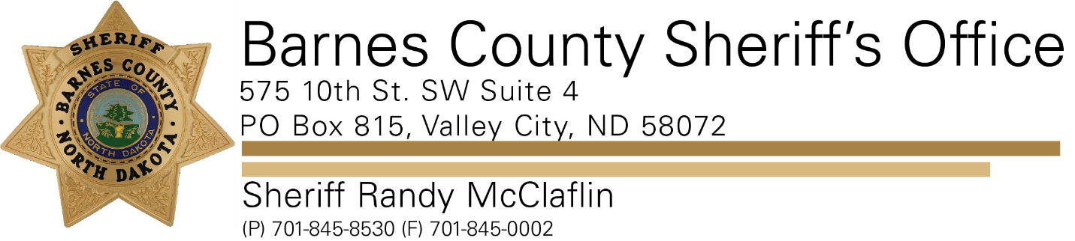

**PRESS RELEASE**

**For Immediate Release- December 2, 2021**

**Barnes County Sheriff’s Office**

**Contact: Sheriff Randy McClaflin**

**On 11/30/2021 a Barnes County woman was sentenced to four years and six months to be served with the Department of Corrections and Rehabilitation.**

**According to court documents Gina Marie Aalgaard Kelly was found guilty on two counts of felony driving under the influence of an intoxicating liquor or any other drugs, one count of felony preventing arrest and one count of misdemeanor driving while license suspended.**

**The sentencing stems from a citizen’s complaint of an erratic driver that occurred on October 19th of this year. Gina Marie Aalgaard Kelly was stopped by Barnes County Sheriff's Deputies and Valley City Police Officers in the one hundred block of 12th Street NE in Valley City. After a short struggle Gina Marie Aalgaard Kelly was taken into custody and charged with DUI-alcohol and drugs-4th or subsequent offense in 15 years among other charges.**

**Barnes County Sheriff Randy McClaflin said this arrest occurred in an elementary school zone during school hours. Thankfully no children were hurt.**

**Sheriff McClaflin would like to remind citizens that driving under the influence is dangerous and a serious offense. Please don’t get behind the wheel if you’ve had anything to drink.**