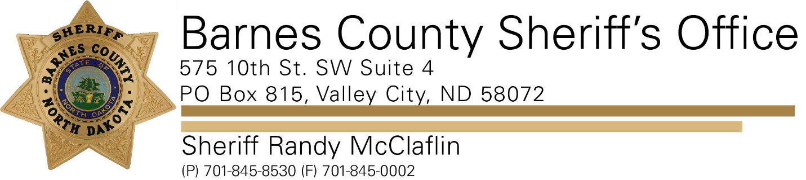

**PRESS RELEASE**

**For Immediate Release- January 10th, 2022**

**Barnes County Sheriff’s Office**

**Contact: Sheriff Randy McClaflin**

**On January 08th 2022 the Barnes County Sheriff’s Office received a report of a one vehicle roll over on Interstate 94 near mile marker 298.**

**A 2004 Dodge Pickup driven by 29-year-old James Hogness, of Fargo ND spun out of control while traveling west bound on Interstate 94. The vehicle entered the north ditch and rolled one time landing back on its wheels.**

**Both passengers of the vehicle, 53-year-old Steven Schrader and a juvenile female both from Fargo ND were uninjured. The driver was also uninjured.**

**It is believed the cause of the crash was due to icy road conditions and weather conditions.**