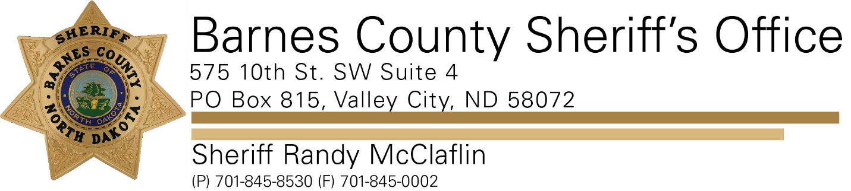

**PRESS RELEASE**

**For Immediate Release- January 25, 2022**

**Barnes County Sheriff’s Office**

**Contact: Sheriff Randy McClaflin**

**The Barnes County Sheriff's Office is investigating a recent aggravated assault.**

**On 01/22/2022 the Barnes County Sheriff's Office was contacted by the Buffalo Bridges Human Service Zone about a two-month-old infant who was admitted into the Sanford Hospital in Fargo. The infant had suffered non-accidental trauma. It was alleged a member of the infants household had caused the non-accidental trauma to the infant. Upon further investigation the father of the infant, Justin Neal Gibson was taken into custody and transported to the Barnes County Correctional Facility where he is being held on a 25,000 cash bond. This incident occurred in the 11600 block of J Street SE Valley City ND.**

**If you have any information regarding this incident, please contact the Barnes County Sheriffs at 701-845-8530.**