2021-22 ND Juried Art Student Art Show
(Governor’s Show)
Valley City Public Schools art students take top awards in the 2021-22 Governor’s Show
*Overall VCPS art students K–12 took 17 State Awards

Junior /Senior High Division (instructor-Stephani Krueger)

State of the Arts Award- Senator Kevin Kramer (This work will be on display in Sen. Kramer’s office)
Aiden Langemo (Grade 7) - Honeydew
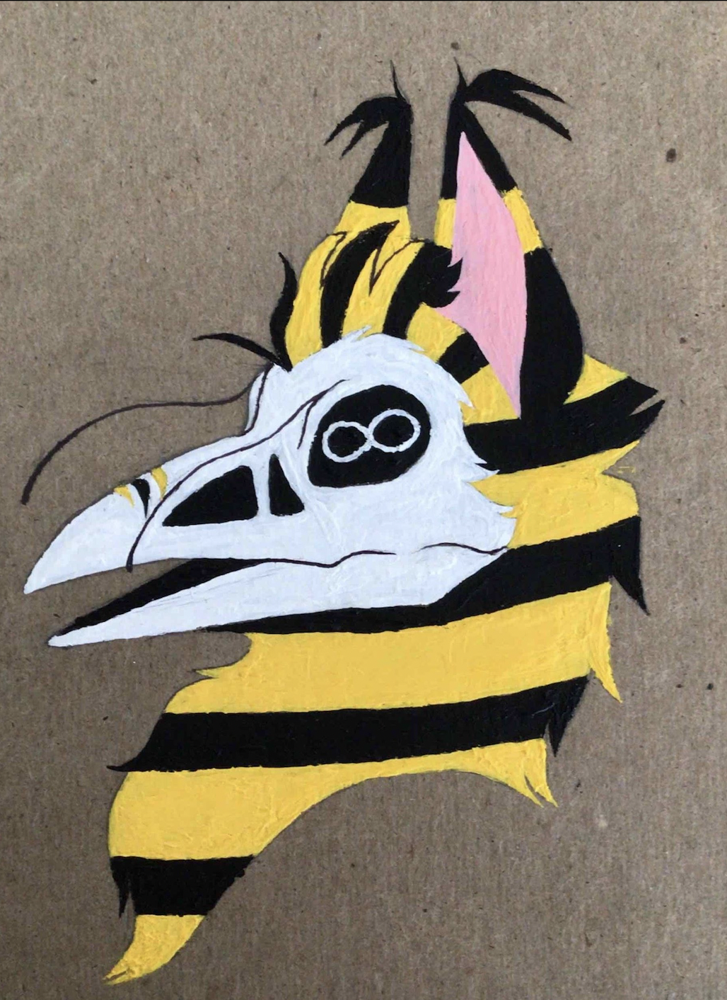

Spotlight Award – (Only 3 students in the state win this award)
Ayden McPartland (Grade 10)- Just

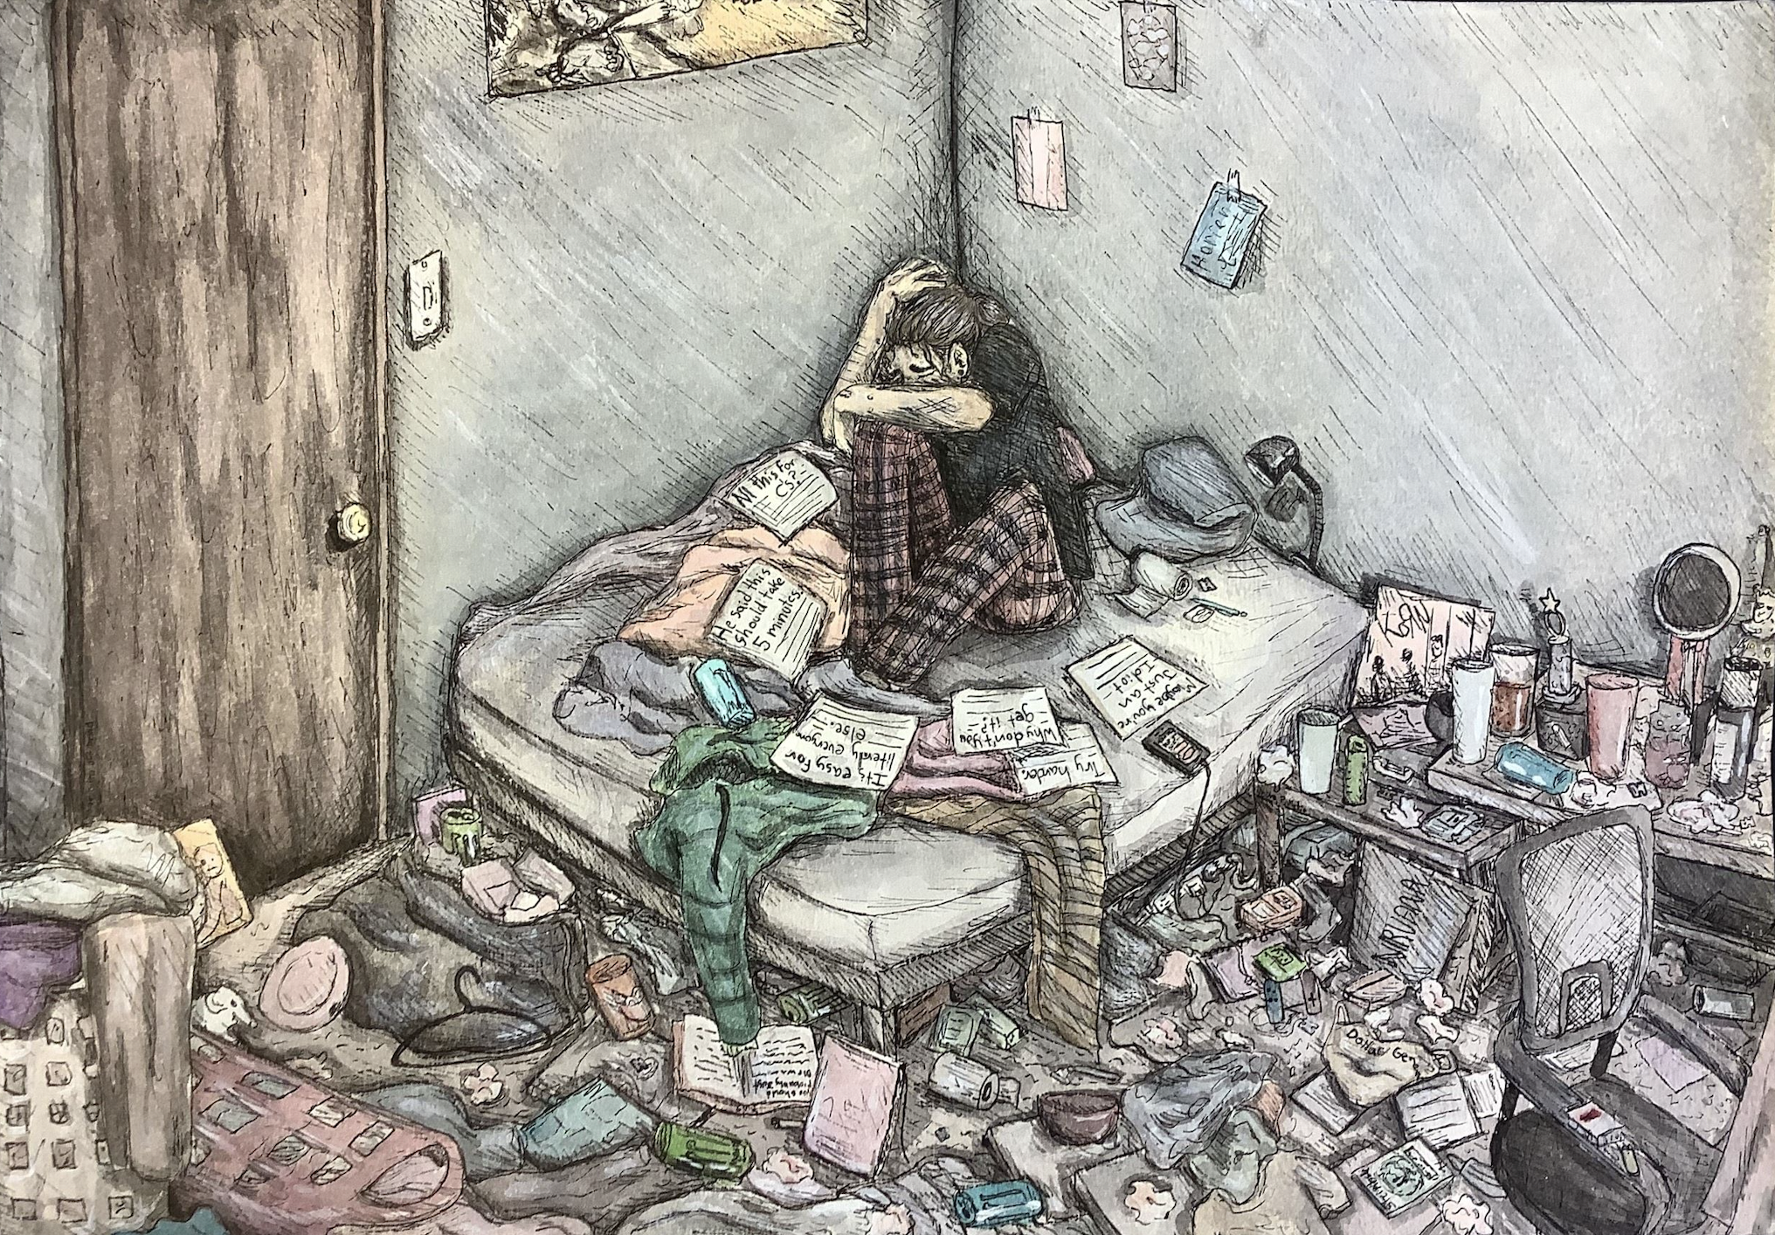

People’s Choice Award- (This award is judged via an online platform)
Corbyn Powell (Grade 8)- A Glimpse in the Night

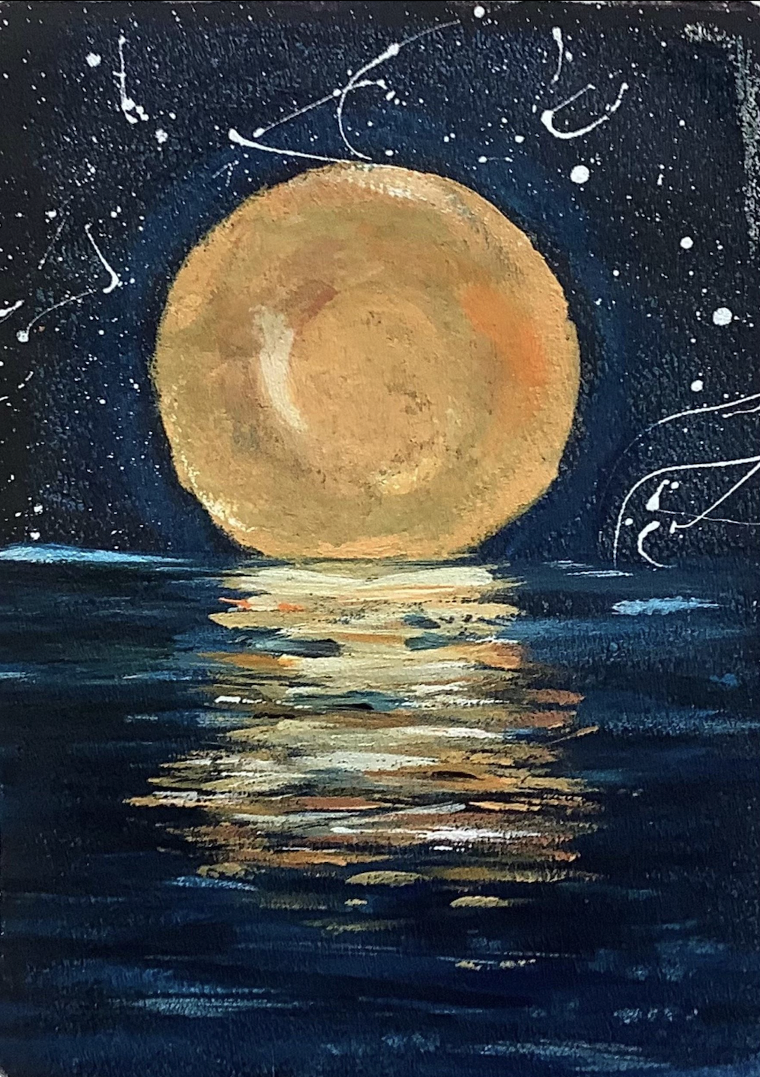

Traveling Show Awards
Gabe Herzog (Grade 11)- Reach
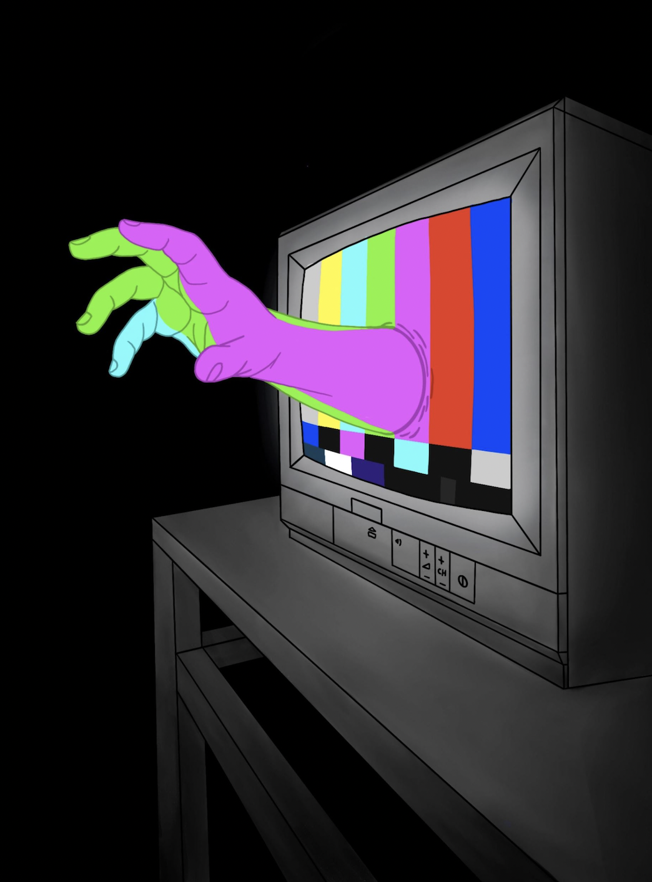

Ayden McPartland (Grade 10)- SI #1
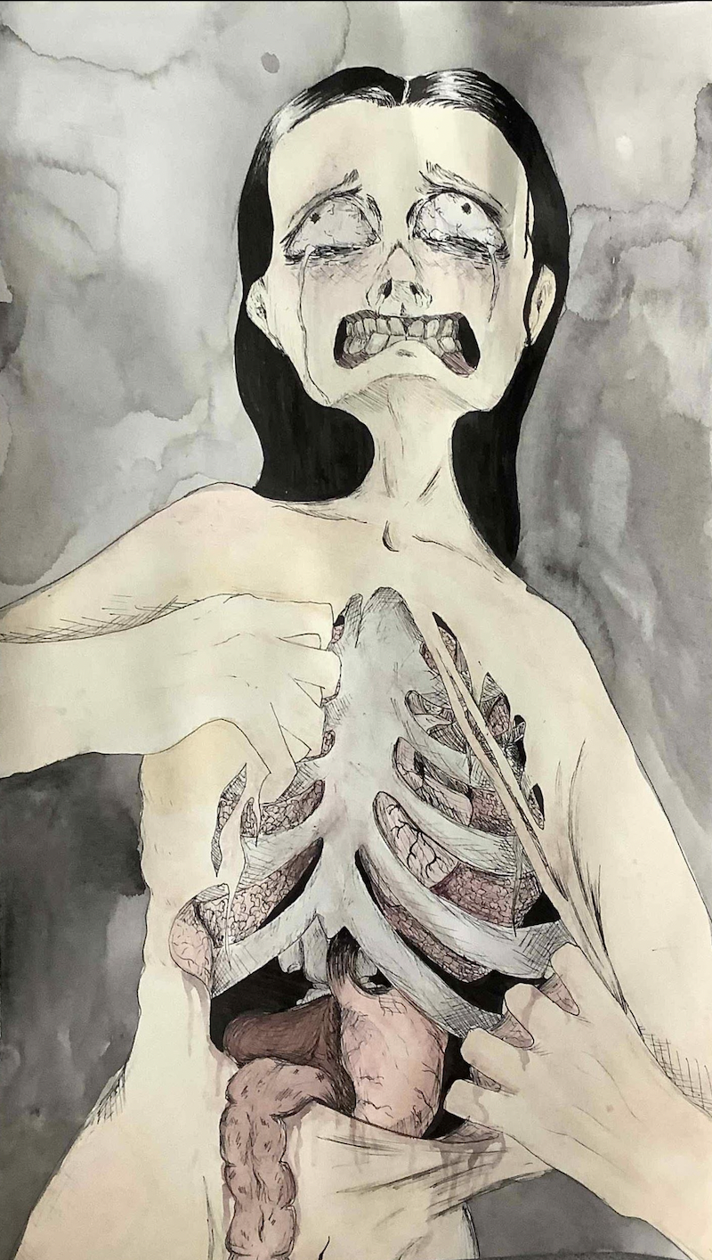

Emily Klein (Grade 12)- Untitled
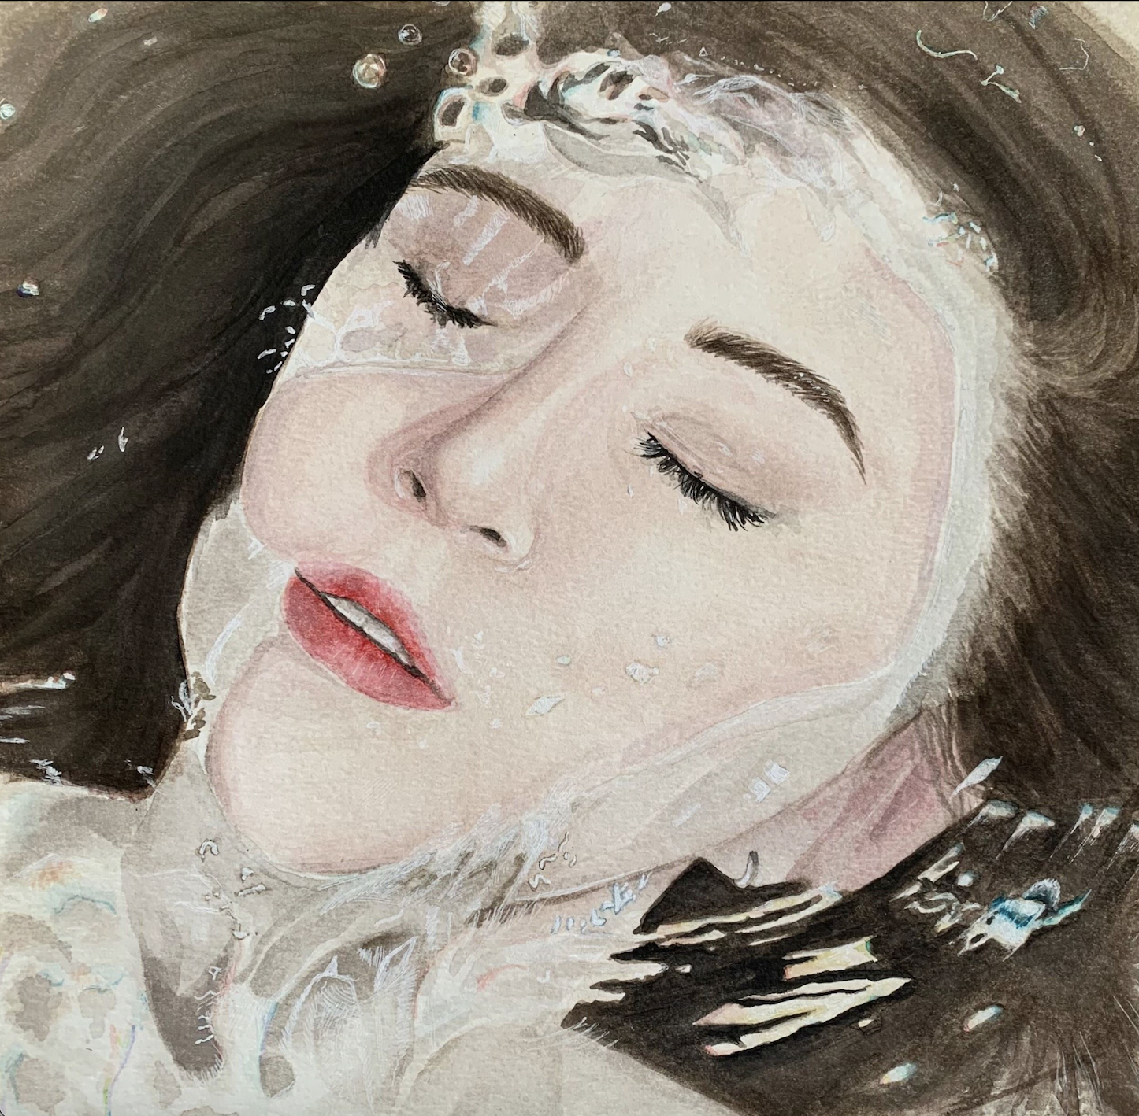

Tessa Kinney (Grade 9)- 50’s Diner
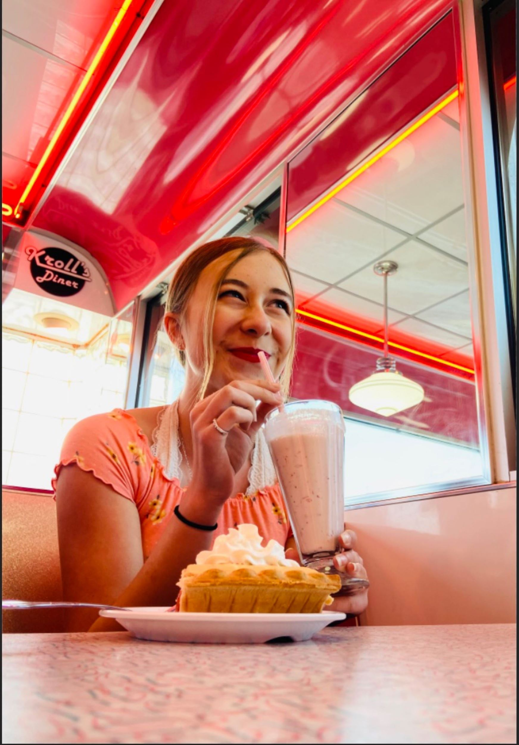

Kaleb McClaflin (Grade 8)- Midnight Sky
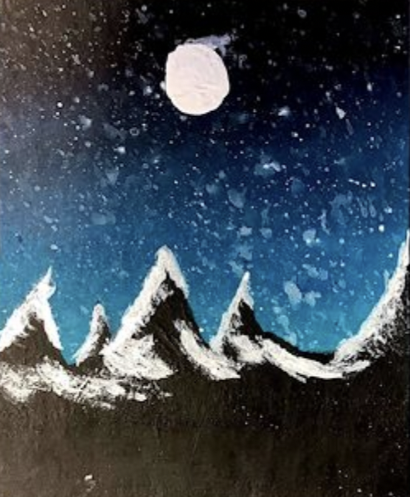

Nora Wolhart (Grade 7)- Nature’s Eye
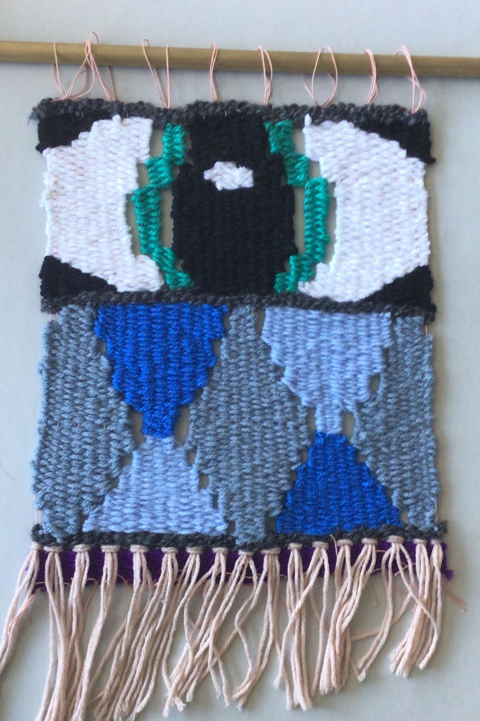

Ellanor Pederson (Grade 7)- Personal Items
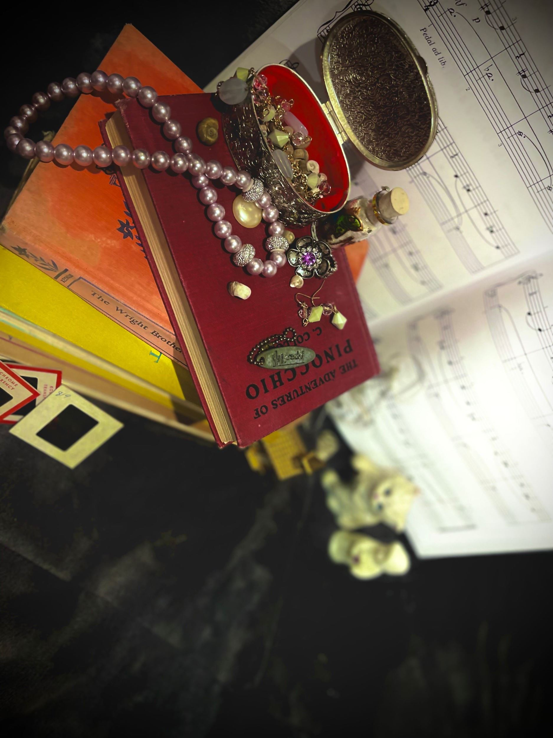

Kellen Westman (Grade 8)- Peanut Butter

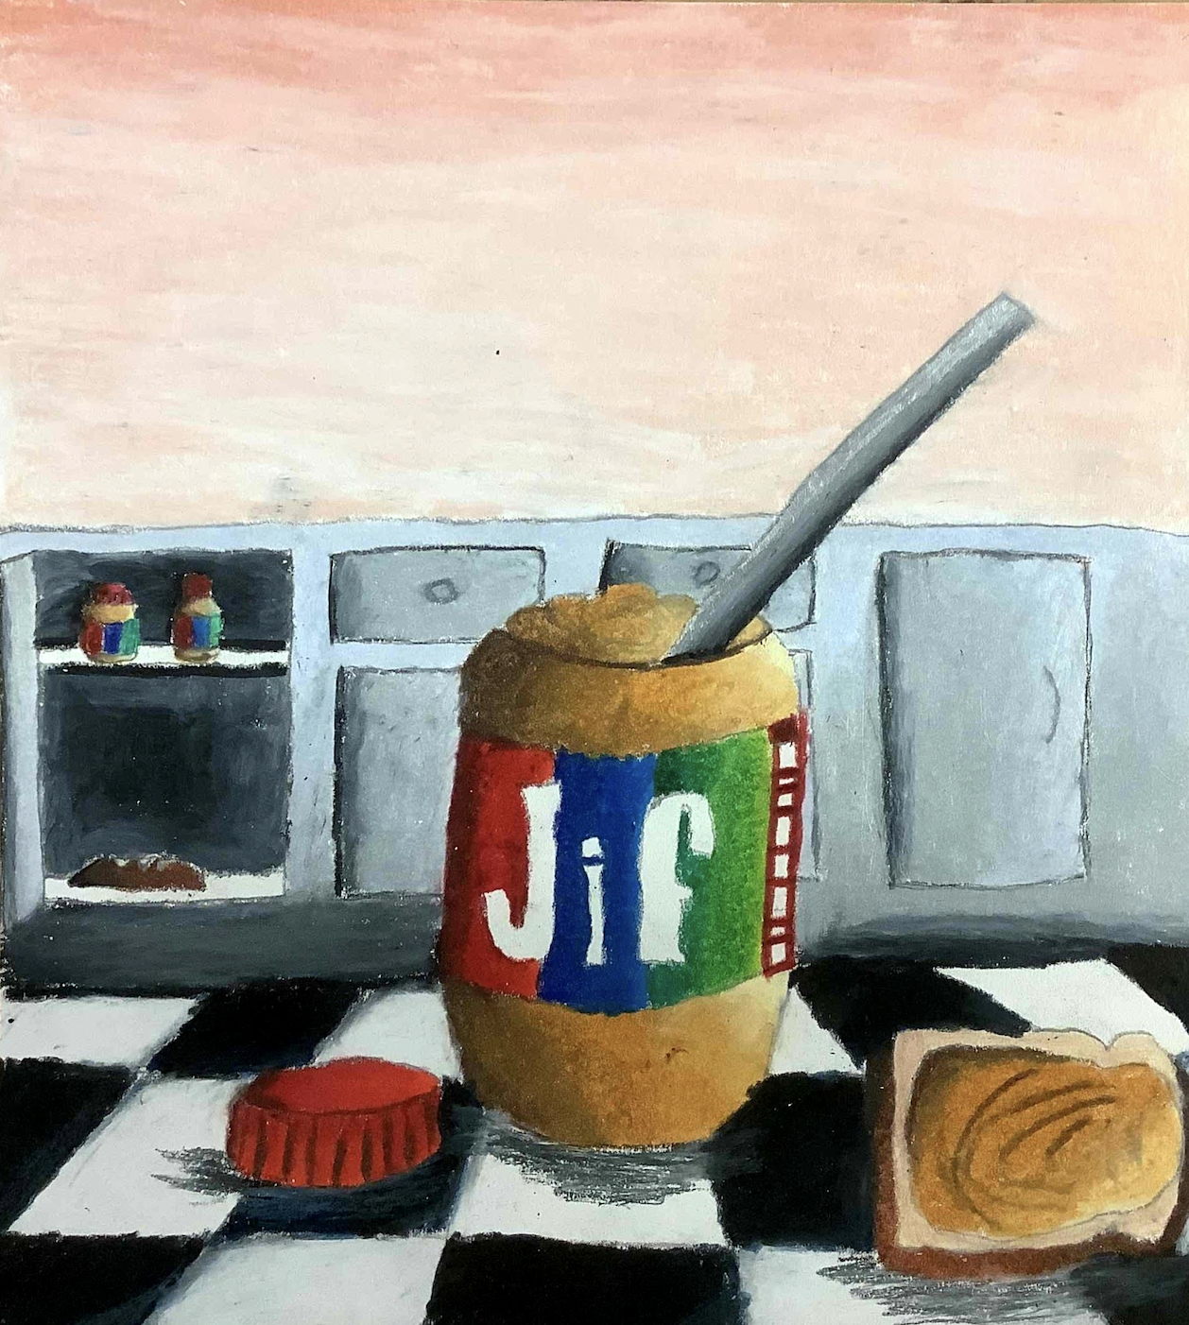

Brenna Storly (Grade 8)- Just a Glass of Water
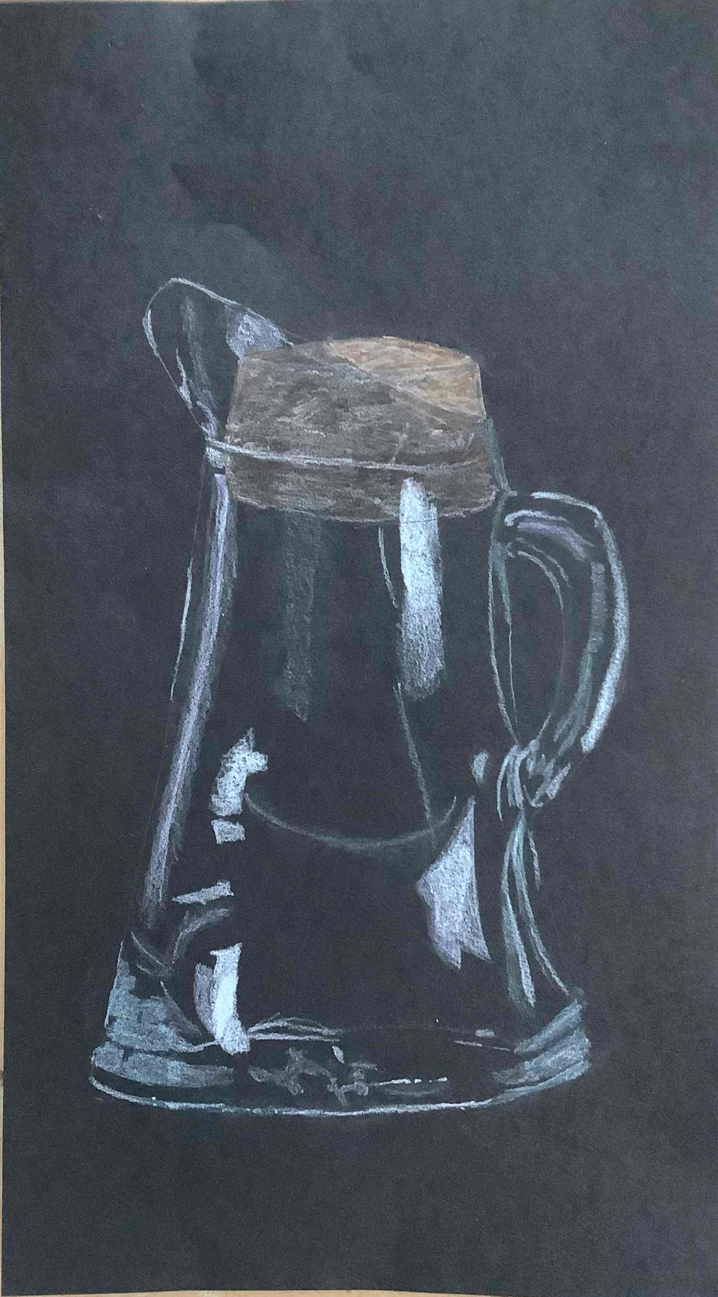

Elementary Division (Brenna Schroder)

People’s Choice Award- (This award is judged via an online platform)
Jarett Borg (4th Grade) – Monochromatic Self Portrait
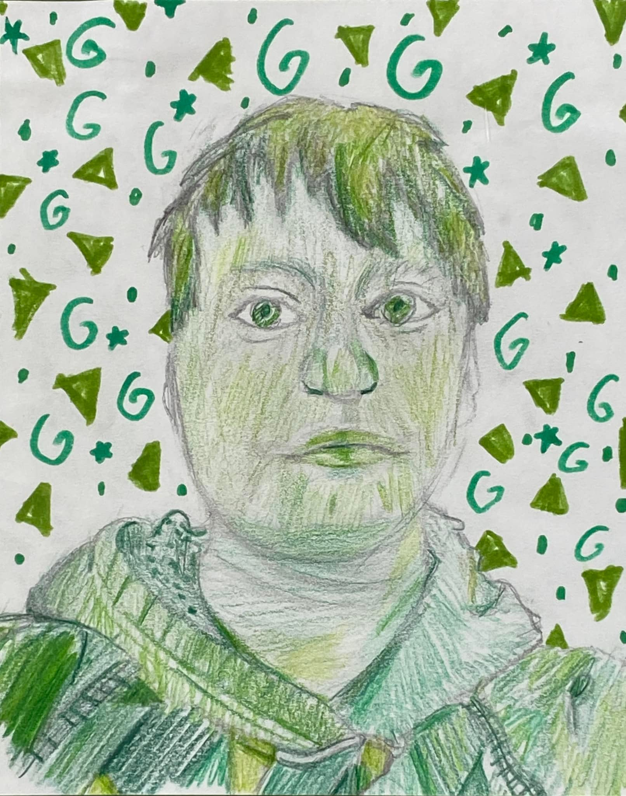

Traveling Show Awards (Jefferson Elementary)
Tayla Delmore (3rd Grade)- Dog Shaking Water
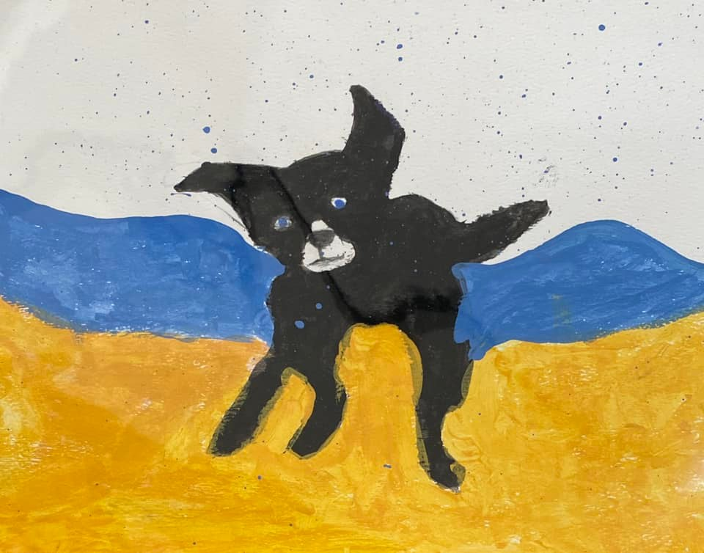

Noah Jorgensen (1st Grade)- Winter Landscape
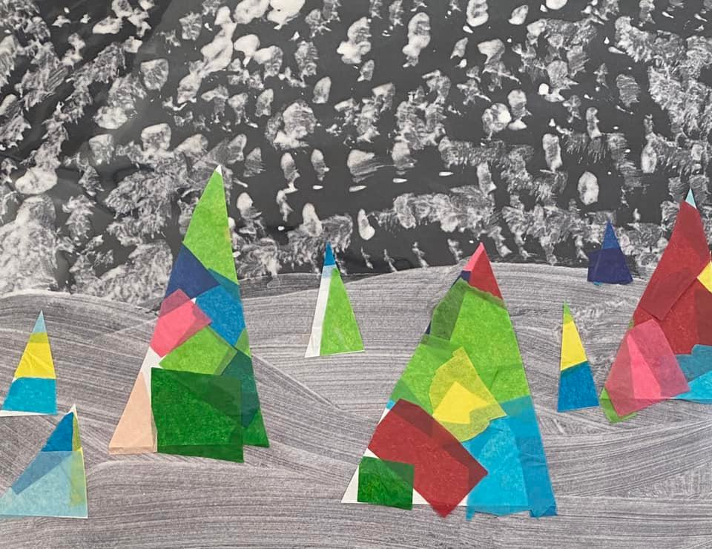

Traveling Show Awards (Washington Elementary)

Parker Roelfsema (6th Grade)- Cartoon Group
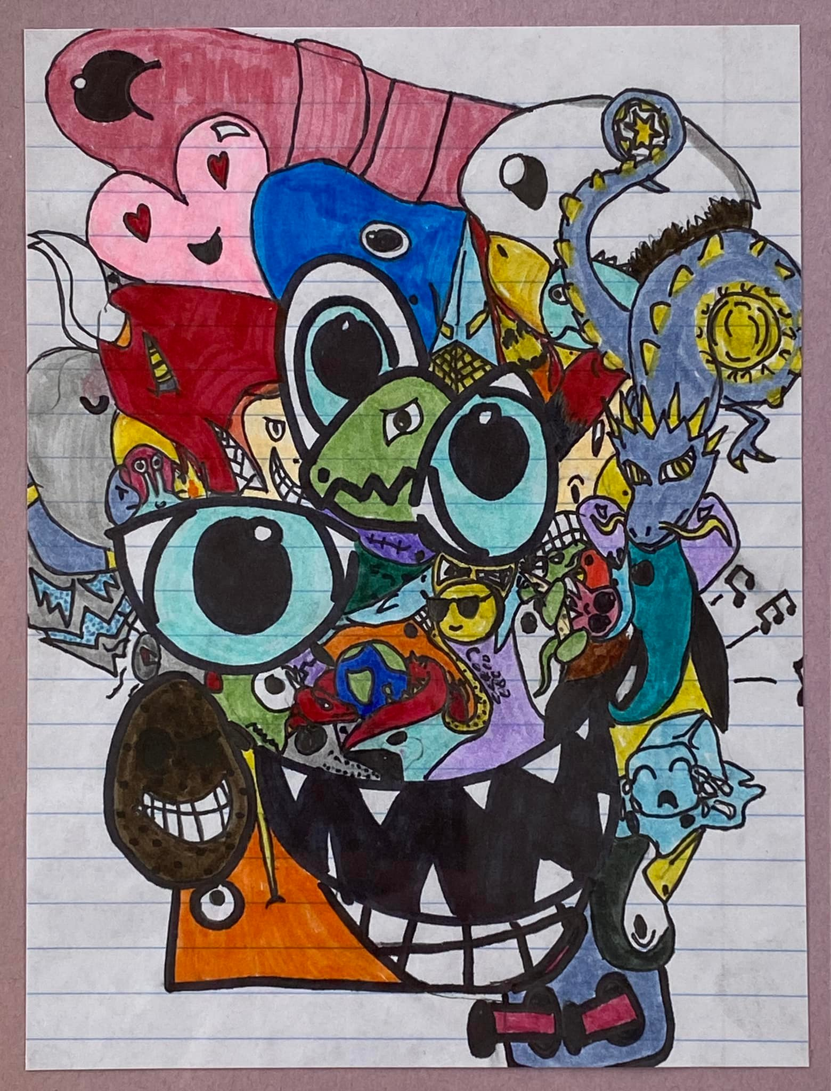

Audrey Jacobson (6th Grade)- Bulbs and Branches
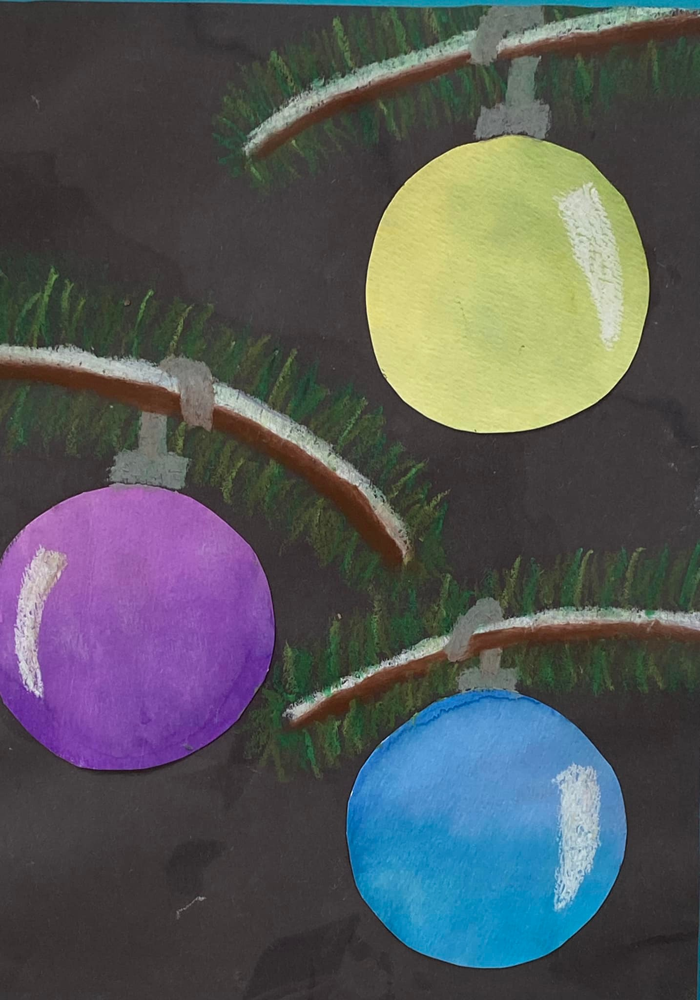

Brody Wendel (6th Grade)- Pop Art Candy

