Stop The Bleed Trainer Instructions

These instructions are provided to qualify a person within your community to teach future STB courses for you. There are three options potential trainers may pursue:
- If you have an eligible trainer that has completed a STB course in the past, they are eligible to be a trainer without any further education or training. They will access the online trainer portal to access instructor materials.
- An eligible trainer attends the NDSU STB course coming to your community. Your trainer will then be deemed eligible to be an instructor and will access the online trainer portal to obtain instructor materials.
- If your potential trainer has never attended a STB course. They can complete the online STB instructor training course and be verified as a trainer via online evaluation at any time.
  - If they would like to do the online training prior to the NDSU STB course in their community, they can complete the training online and could teach the upcoming course in their community.
STB Instructor Program Instructions
- To access the online STB Instructor Program, visit Instructor Program – Stop the Bleed Coalition

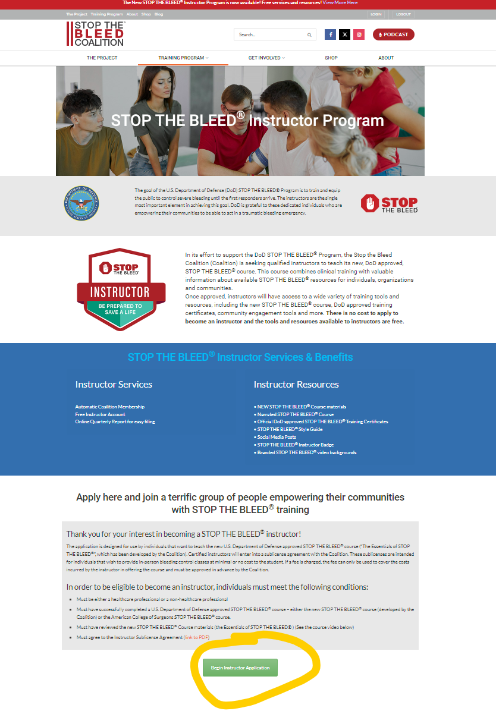

- Complete the instructor application
  - In the instructor application, they ask if you have successfully completed a US Department of Defense or Surgeons STB course. If your instructor meets criteria 1 or 2 from above (have already taken a STB course), they should select “yes” in the application.
    - In a few days they will receive access to the instructor portal and be able to access all material needed to teach a STB course.
  - If your trainer meets criteria 3 from above, they should select “no” to complete the online verification to become a trainer.
    - Once you receive an email that your instructor access is granted, you will follow prompts within STB to complete the online training and schedule a session with an online instructor to verify your instructor skills.

- If your identified community instructor would like to teach the upcoming NDSU STB course coming to your community, please contact the instructor coming to your site to notify them that your trainer desires to teach the upcoming course.
Please reach out to carrie.nelson@ndsu.edu if you have any questions on how to become a STB trainer.

