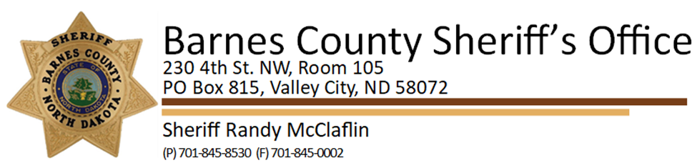

December 30, 2025

Re: Scam Calls Reported

The Barnes County Sheriff’s Office is warning residents about scam phone calls in which individuals falsely claim to be law enforcement and request money or personal information. The callers identify themselves as deputies with the Barnes County Sheriff’s Office and may leave a phone number that appears to be the Sheriff’s Office number but is not; the number provided of 701-248-0401 leads to an automated system.
These calls are fraudulent. Law enforcement agencies will never request payment or sensitive information over the phone.
Residents are advised to hang up immediately on suspicious calls and report them to 701-845-8530.

