Photo Credit: Nathan Ingram

* The Dallas County Conservation Foundation is a 501(c)3 non-profit

organization, making your gift tax-deductible.

* Donations of all amounts are appreciated. No gift is too large or small.
* Your gift goes directly to trail construction and rehabilitation.
* Join countless supporters in saying, “Yes! I want to support the trails of Dallas County!”

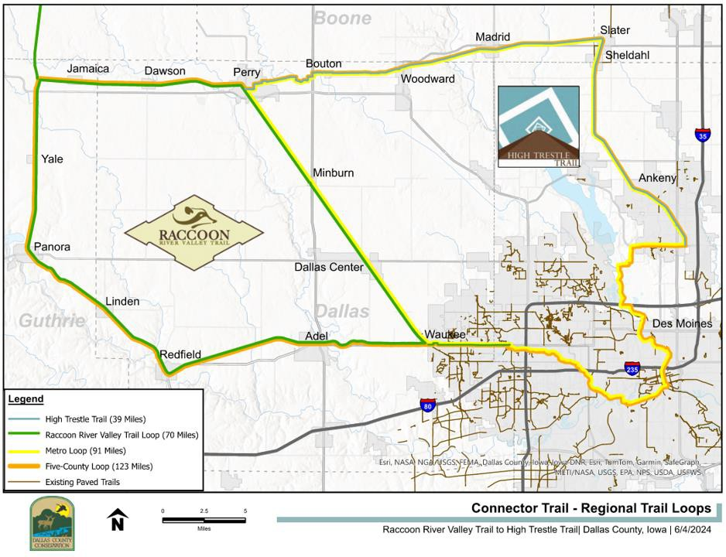

* Phase IV Adel – Ortonville Bridge and Trail Rehab
* Future Trail Rehab Projects

Support

the Trails of Dallas County

**Dallas County Conservation Board** [www.dallascountyiowa.gov/conservation](http://www.dallascountyiowa.gov/conservation) 14581 K Ave, Perry, IA 50220

515-465-3577

[conservation@dallascountyiowa.gov](mailto:conservation@dallascountyiowa.gov)

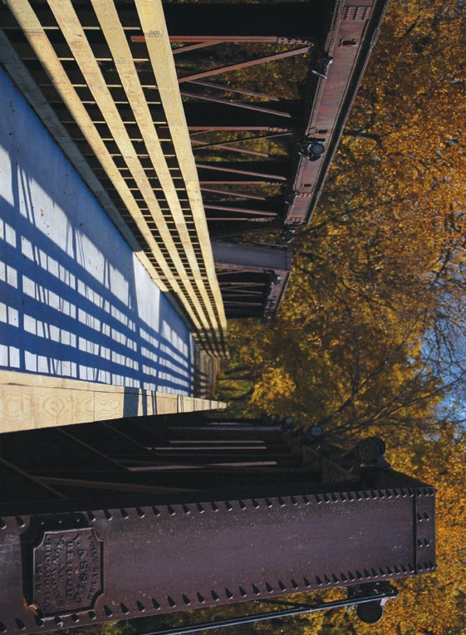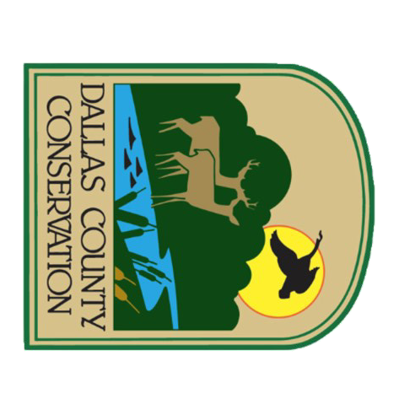

**Together, We Build a Stronger Future for Dallas County's Trails!**

Support the Trails of Dallas County was launched in 2023 to encompass all our trail projects. With your help, we can continue to improve and maintain our trail systems. Dallas County is home to two of the finest trail networks in the country, and your contributions will directly impact our continued efforts to enhance these trails.

Thanks to your continued support, we are excited to announce the completion of the nine-mile extension of the High Trestle Trail. Additionally, we have completed Phases II and III of our rehabilitation plans on the south loop of the Raccoon River Valley Trail, which included repairing six bridges and replacing over six miles of asphalt with concrete.

Phase IV Bridge and Trail Rehab - Adel to Ortonville will begin in 2025, allowing us to continue these crucial upgrades. It will include repairing and widening the five remaining bridges on the south loop, removing the asphalt, and replacing it with concrete. The scope of Phase IV - Adel to Ortonville will be similar to that of Phase II - Redfield to Linden.

Last year, we raised over $50,000 together. If each supporter donates just $10, we can surpass that total by an additional $10,000! Your generosity is essential for maintaining our trails.

Past contributions to the "Let's Connect" and "Support the Trails of Dallas County" initiatives have helped us leverage those funds into over five million dollars in grants since 2015!

Thank you for your continued support. Together, we can ensure that our trails remain a valuable resource for future generations.

Sincerely,



Curt Cable

Director, Dallas County Conservation Board [www.dallascountyiowa.gov/conservation](http://www.dallascountyiowa.gov/conservation)



*Please cut along line and include this slip with your mailed donation.*

I support the trails of Dallas County! My gift of $ is enclosed.

Name Address City State Zip Email Phone ( ) -

Please make checks payable to:

***Dallas County Conservation Foundation***



14581 K Avenue, Perry, IA 50220

515-465-3577

**Scan here to give online to Dallas County Conservation Board:**

**Or visit dallascounty.seamlessdocs.com/f/ DCCBDonation**