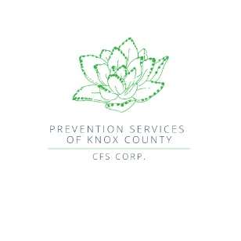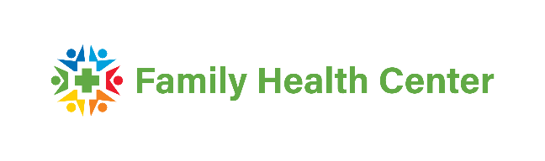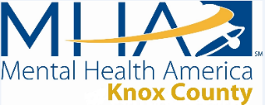****

**BE THE ONE TO… CONNECT, TO BE THERE, TO FOLLOW UP,**

**AND TO KEEP THEM SAFE**

Each year in September, the Knox County community supports National Suicide Prevention Awareness Month to raise awareness of Suicide Prevention. The most notable event, the Annual Suicide Prevention Walk, brings together mental health agencies and those affected by suicide to make an impact on reducing suicide. This year’s walk is on Saturday, September 21st at Vincennes University’s Outdoor Track.

Check in for the walk begins at 8:30 am and the Opening Ceremony starts at 9:00 am with the walk immediately following. Individuals can choose the length of their walk, 0.5, 1, 2, 3 or 5 miles.

Community resource agencies will be in attendance to provide information on programs and services available to help those in need.

Suicide is the 12th leading cause of death in the United States as per the National Institute for Mental Health, claiming more than 45,900 people in 2020. Suicide is tragic but is often preventable. How can we help reduce those numbers? By coming together and sharing our stories, our resources, and sometimes as simple as asking, “How is your day?”

There are new ways of receiving help including a new 24-Hour mental health crisis line operated by the Family Health Center’s Green Door Staff. That number is 1.833.644.3575. Also available is the national 988 hotline that can connect crisis staff with those in need by text or call.

The walk provides time for those affected by suicide to come together and share their stories, which helps in the healing process. These stories can provide insight and potential warning signs used in helping others during their time of crisis. By joining together and sharing resources, we can all help in reducing the stigma of mental health and make it easier for those seeking help to receive the services they desperately need.

Over 57 million people in the United States struggle with mental health issues annually. More than 1,000 Hoosiers lose their life to suicide each year and nationally 12.2 million people have seriously thought about suicide each year. To learn more about identifying the warning signs, go to <https://www.nimh.nih.gov/health/topics/suicide-prevention>

To register for the Walk and or purchase a shirt in support of this cause, go to <https://forms.gle/pJktM7MQyTg93kP29>. This is a family friendly event to spread hope and awareness. For more information call or text 812.396.8808 or email [mhakcindiana@gmail.com](mailto:mhakcindiana@gmail.com)