News Release
Office of the President and Provost

September 5, 2019

ISU President, Terre Haute Mayor Discuss Changes to Homecoming

Indiana State University President Deborah J. Curtis and Terre Haute Mayor Duke Bennett on Thursday discussed the status of previously announced changes to Homecoming.

A week of festivities culminates with the Homecoming football game at 1p.m. October 12 against Western Illinois.

Homecoming events will include Multicultural Career Connection, bringing students, alumni and employers together; Paint the Town Blue, where students decorate local businesses to show Sycamore pride; and “Homecleaning,” where students clean Wabash Avenue on the day after the Homecoming game.

“Homecoming is a celebration that connects alumni, faculty, staff, students and the community as we cheer on the Sycamores,” Curtis said. “Thanks to great collaboration among the university, the City of Terre Haute, law enforcement, and business owners, we have a plan to maintain everyone’s enjoyment while ensuring safety and a family-friendly atmosphere.”

Said Terre Haute Mayor Duke Bennett: “The City of Terre Haute is committed to working with ISU to ensure that everyone can enjoy a safe and fun Homecoming. I appreciate the spirit of cooperation between ISU and the community, and I want to thank President Curtis and her team for their work with the City on these joint efforts.”

These are the policies:

MODIFICATIONS TO TENT CITY

Tent City will be moved inside the stadium with a smaller footprint and fewer tents. Individuals who want to visit Tent City will be required to have a ticket for the game. Students may enter with their ISU student ID. The former Tent City location will be opened for additional and much needed parking. Various groups that normally host tents at Tent City will be provided space on campus to host their alumni following the parade and prior to going to the stadium. In addition, some groups may be located in the newly configured tailgating area.

LAW ENFORCEMENT

A collaboration among the Terre Haute City Police, ISU's Public Safety Department and the Sheriff's Department will significantly increase the number of officers patrolling Wabash Avenue, the Stadium and adjacent areas. Officers will also be strict about enforcing permit requirements for pop-up business locations, open containers and related laws.

TAILGATING

ISU appreciates support of Sycamore football as fans look forward to another great season in 2019. The university asks fans to please follow these rules.

GENERAL
• Groups of 25 people or more must contact the Indiana State Athletic Department, 812-237-3047, at least seven days prior to the event.
• Individuals who interfere with others’ enjoyment through the use of loud, abusive language and/or behavior may be asked to leave.
• Noise amplification and music must be kept to a reasonable level.
• In keeping with Indiana law, persons under 21 years of age shall not, under any circumstances, have possession of alcoholic beverages. Minors must be accompanied by a parent or responsible adult.
• Soliciting or selling goods/services will not be permitted on stadium grounds without prior approval from the University.
• Weapons of any kind are prohibited.

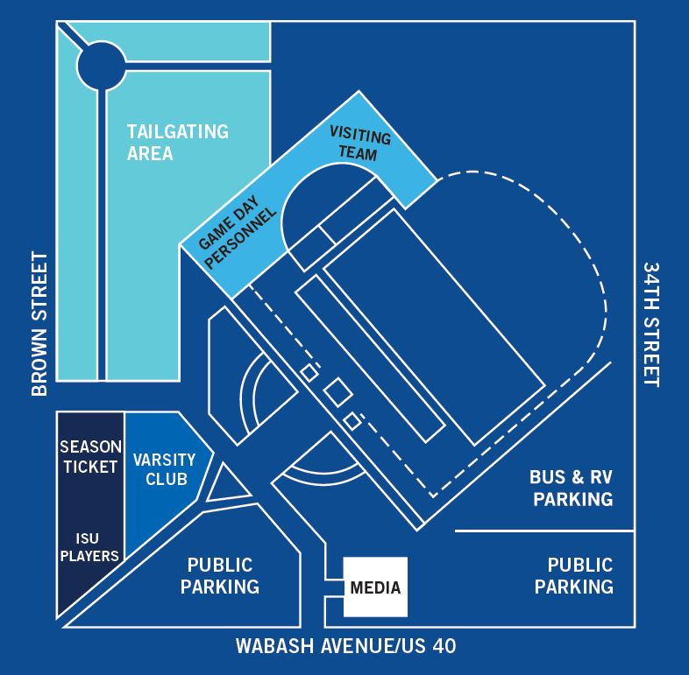

TAILGATING/TENTS/PARKING
• Tailgating is to take place in the area designated by Indiana State University. The tailgating area will close at kickoff. For games other than Homecoming, the area will reopen at halftime and remain open until one hour after the conclusion of the game. The tailgating area will remain closed during the entire game on Homecoming.
• Tents and awnings must be 12’x12’ or smaller. Exceptions may be made for season-long partners. Contact the Athletic Department at 812-237-3047 for more information.
• Tailgating participants are responsible for keeping Memorial Stadium and the surrounding area clean. Trash bins will be located throughout the grounds.
• Buses and RV’s are to park on the east side of Memorial Stadium and are subject to the same rules and regulations of the tailgating area

FOOD/BEVERAGE
• No open containers of alcohol will be permitted outside the designated tailgating area.
• Glass bottles and containers are prohibited. Alcoholic beverages must be limited to a maximum container size of one gallon. Beer kegs and party balls are prohibited in any parking area.
• All beverages should be consumed from plastic or paper cups or aluminum cans.
• Fires, unless contained in a fire pit, are prohibited. Propane and charcoal grills are permitted. Please properly dispose of all hot coals.

Additional information can be found on ISU’s Homecoming webpage: https://www.indstate.edu/about/homecoming.

Media contact:
Mark Alesia, Director of Communication, Indiana State University
(O) 812-237-3837
(C) 812-229-8020
mark.alesia@indstate.edu

