**MEDIA RELEASE** CONTACT: DeeDee Travis

DATE: June 6, 2023 CCH Community Relations

(207) 454-9227

[deedee@calaishospital.org](mailto:deedee@calaishospital.org)

Photo Caption: L to R: Imaging Manager Kristy Surles, RT(R)(CT)(BD) with Mammographers Carla Jundt, RT(R)(CT)(M) and Billie Jo Ham, BS, RT(R) are pictured with the new state of the art 3D Mammography equipment now available at CCH. Appointments are being scheduled for this new system.

**CCH Introduces New 3D Mammography Machine**

A new, state-of-the-art Senographe Pristina 3D mammography machine is the most recent addition to the Calais Community Hospital radiology department.

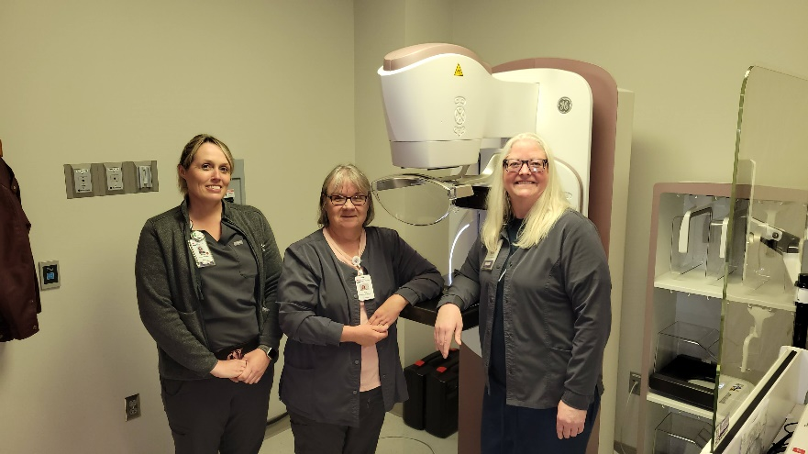3D mammography, the next step beyond 2D, is the highest standard of care for mammograms.  Calais Community Hospital’s new 3D system captures high-quality images while automatically reducing radiation exposure to the minimum necessary.  The Senographe Pristina produces clearer images that will make it easier to catch breast cancer early.    The clarity of the images should reduce the number of call backs, and when call backs are necessary, the new system makes it easier to provide patients with a definitive answer on their results.

“We are offering patients an exam that is quick and accurate, and the patient can be confident in their results,” said Mammographer Billie Jo Ham, B.S., R.T. (R).  “I am thrilled we can provide this state-of-the-art technology to our patients and community.”

The hope is this new system will encourage women to be more compliant with screening guidelines, and not skip their mammograms.   Mammograms are a critical part of maintaining a healthy life and we want it to be an easy, comfortable experience for women.   While the equipment is new, it is operated by the same highly skilled, compassionate, and experienced CCH staff – the same friendly faces will be present to make the process as pleasant and efficient as possible.

Investing in state-of-the-art technology is part of Calais Community Hospital’s mission to improve the health of community members.   Investing in new mammography technology also demonstrates the hospital’s commitment to increase cancer screening rates among residents in Eastern Washington County.

Since the transition to Calais Community Hospital, the hospital has invested much of its financial resources back into the hospital.  These capital investments include a new bone density machine, MRI, ultrasound equipment, anesthesia equipment, bi-pap machines, pulmonary function testing (PFT) equipment, orthopedic surgical equipment, and more.

If you are due for a mammogram and have been putting it off, contact your primary care provider about sending a referral to CCH.  It is an important screening to get up to date on.  If breast cancer is found early, there are more treatment options and a better chance for survival.  Women whose breast cancer is detected at an early stage have a 93 percent or higher survival rate in the first five years.

**To the women in our community** - remember to take care of yourselves so you can continue to care for those you love.

**To the men in our community** - remind the women important in your life that screenings are essential and help them remember to schedule it.

Protect your health and support your local hospital and its staff by requesting a mammogram referral to Calais Community Hospital from your primary care provider today.

###