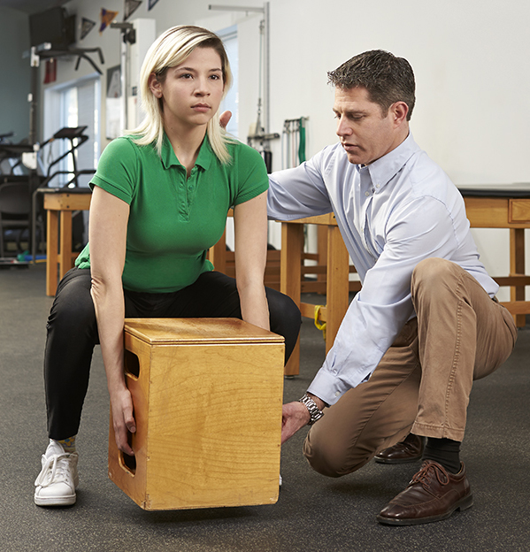
Amid the hustle and bustle of our everyday lives, it's easy to forget about safe lifting. But before you try lifting dinner out of the oven, bending over to pick up a box or squeezing a TV into the back seat or trunk of your car, consider the following tips to ensure you don't spend time flat on your back!
Healthy Lifting Tips
Get help. The best way to avoid injury is to get help from a machine or another person(s).
Plan the move. Inspect the pathways and destinations to ensure they are clear before you begin the lift.
Keep a wide, balanced base of support. Typically, keeping your feet wider than your shoulders helps distribute weight evenly throughout your lower body, decreasing pressure on your lower back. It also will help you remember the next point.
Bend at the knees; not your waist. Bending at the knees shifts the weight of the object you are lifting from your low back (small postural muscles) to your gluteal (buttock) muscles, quadriceps and hamstrings, which are stronger power muscles.
Tighten your abdomen. The simple maneuver of pulling in or tightening your abdomen activates your body's own natural weight belt. To do this, pull your belly button up and in to the back of your spine but don’t hold your breath. Hold this position for the duration of your lift. This braces your low back and will "lock" you into place.
Keep the object as close to your body as you are able during the lifting process. Lifting an object away from your abdomen will exert more pressure on your back.
Keep your head up, your chin in and look straight ahead. This will help you lift with your head and shoulders first.
Now you're ready to lift! Stand straight up and you should feel no increase in pressure go through your low back. You can apply these simple techniques in any situation.
Should you suffer an injury or experience recurring pain, call your local NovaCare Rehabilitation center today to get on the road to recovery!

NovaCare Rehabilitation Locations in Southern Illinois
Benton Carbondale Marion Mt. Vernon West Frankfort
618-439-3399 618-529-3201 618-997-9497 618-242-1100 618-937-6200

