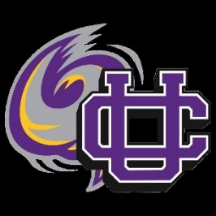

2020 UCMS Cross Country Schedule

All meets begin at 4:45 unless otherwise noted

August 20- Dresden Middle School Jamboree

August 22- Fulton County Invitational 9:00 am

August 24- OC Run @ OCCHS

August 31- Milan Middle School

Sept. 10- UCMS @ Graham Park

Sept. 12- Camden 9:00 am