MARSHALL PUBLIC SCHOOLS
On November 5, 2021, the announcement of an administrative procedure, of which the MPS Board of Education was aware, suspended an all-district mask mandate for the interior of all MPS buildings, beginning immediately. Unvaccinated individuals should consider wearing a face covering for their personal safety and that of others.
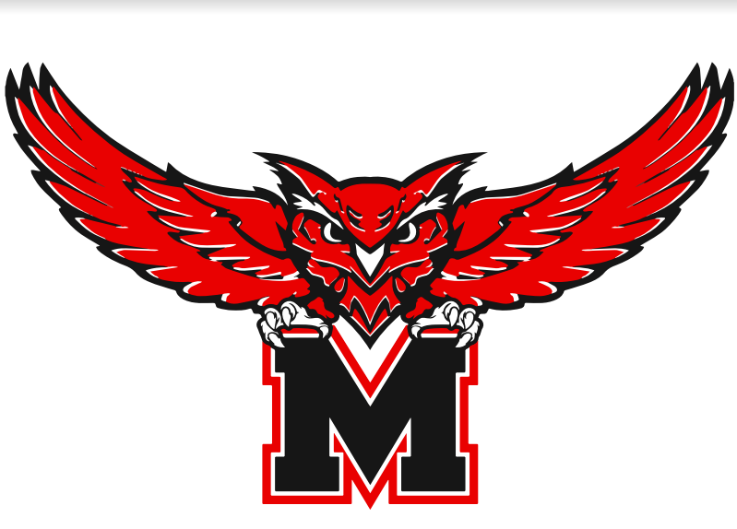

MPS Revised Plan for the Safe Return
to In-Person Instruction
and the Continuation of COVID Relief Services

2021 – 2022 School Year

CURRENT AS OF 11-5-2021

TABLE OF CONTENTS

Introduction . . . . . . . . . . . . . . . . . . . . . . . . . . . . . . . . . . . . . . . . . . 2

Quarantines . . . . . . . . . . . . . . . . . . . . . . . . . . . . . . . . . . . . . . . . . . . 4

Vaccinations . . . . . . . . . . . . . . . . . . . . . . . . . . . . . . . . . . . . . . . . . . 7

Contract Tracing . . . . . . . . . . . . . . . . . . . . . . . . . . . . . . . . . . . . . . . 8

Diagnostic Testing/Screening . . . . . . . . . . . . . . . . . . . . . . . . . . . . . 9

Community Consultation . . . . . . . . . . . . . . . . . . . . . . . . . . . . . . . . 10

Strategies to Reduce Learning Loss . . . . . . . . . . . . . . . . . . . . . . . . 27
The Safe Return to In-Person Instruction
and the Continuation of COVID Relief Services
for the 2021 - 2022 School Year
(This plan will be evaluated every 30 days [or sooner] by MPS Board of Education and Administration,
then revised if necessary.)

(This report will be available in Spanish posted on the Marshall Public Schools website. If you need or know someone who needs this plan translated into another language or read to them, please contact
Dr. Carol Maher at 660-886-7414 or cmaher@marshallowls.com)

It is the strong belief of the Marshall Public Schools Board of Education and Administration, based on national and state research, that students and families benefit from in-person learning and socializing with other children. Safely returning to in-person instruction in the fall 2021 is our priority.
Marshall Public Schools District has been working in varied models over recent months to address concerns over the safety of students and adults, while maintaining engaging instruction and meaningful feedback from community members and public health officials. These models have ranged in-seat and blocked-scheduling models, to hybrid models, and to all-distance instruction.
We have not only maintained efforts to educate all MPS students in many ways, but have continued to compensate teachers and support staff. Our mitigation procedures have proven to be successful in keeping students and faculty safe. It is our mission to continue to maintain safety, while educating children in the best possible manner.
During the compiling of this report, it became evident that the entire community of Marshall has been, and continues to be, very concerned about MPS students, those in early childhood and those scheduled to graduate in the spring of 2022. The impact of the pandemic was great on all students, but those identified the most often where ones who live in poverty, are homeless, live and speak in homes of non-English speaking families, and have various disabilities. For those students, this report should serve as a lifeline.
With new guidance from The U.S. Department of Education, the CDC, and the Saline County Health Department, district plans for the safety and security of students and staff been updated. As from its inception, our plans will remain fluid to best guide the district by reflecting the current climate of local, state, and national recommendations for student and adult safety and success. The overarching goal of Marshall Public Schools is to provide our students an educational experience, filled with promises and opportunities.

Mr. Bryon Jacques, MPS Board of Education President
Dr. Carol Maher, MPS Superintendent of Schools

REVISIONS TO THE SAFE RETURN TO SCHOOL PLAN
2021 – 2022 SCHOOL YEAR
(This information is subject to change during the year upon evaluation of the district
and community health status.)

1) On November 5, 2021, the announcement of an administrative procedure, of which the MPS Board of Education was aware, suspended an all-district mask mandate for the interior of all MPS buildings, beginning immediately. Unvaccinated individuals should consider wearing a face covering for their personal safety and that of others.

2) According to a federal order issued by the CDC, masks are required on public and private school buses. Even in schools where masks are not mandated, this order is a requirement and may not be overturned by the local school district.

CENTER FOR DISEASE CONTROL (CDC) RECOMMENDATIONS

The CDC recommends that all teachers, staff and eligible students be vaccinated as soon as possible. However, schools have a mixed population of both people who are fully vaccinated and people who are not fully vaccinated. Elementary schools primarily serve children under 12 years of age who are not eligible for the COVID-19 vaccine at this time. Other schools (e.g., middle schools, K-8 schools) may also have students who are not yet eligible for COVID-19 vaccination. Some schools (e.g., high schools) may have a low percentage of students and staff fully vaccinated despite vaccine eligibility. These variations require K-12 administrators to make decisions about the use of COVID-19 prevention strategies in their schools and are reasons why CDC recommends universal indoor masking regardless of vaccination status at all levels of community transmission.
The CDC recommends schools maintain at least 3 feet of physical distance between students within classrooms, combined with indoor mask wearing by people who are not fully vaccinated, to reduce transmission risk. Cohorting can be used to limit the number of students, teachers, and staff who come in contact with each other, especially when it is challenging to maintain physical distancing, such as among young children, and particularly in areas of moderate-to-high transmission levels.
Together with local public health officials, school administrators should consider multiple factors when they make decisions about implementing layered prevention strategies against COVID-19. Since schools typically serve their surrounding communities, decisions should be based on the school population, families and students served, as well as their communities. The primary factors to consider include:
- Level of community transmission of COVID-19.
- COVID-19 vaccination coverage in the community and among students, teachers, and staff.
- COVID-19 outbreaks or increasing trends in the school or surrounding community.
- Ages of children served by K-12 schools, the associated social and behavioral factors that may affect risk of transmission, and the feasibility of different prevention strategies.

CDC Recommended Prevention Strategies
- Promote vaccination
- Encourage consistent and correct mask use
- Observe physical distancing
- Screening testing to promptly identify cases, clusters, and outbreaks
- Improve ventilation
- Monitor handwashing and respiratory etiquette
- Encourage students and staff to stay home when sick and getting tested
- Conduct contact tracing, in combination with isolation and quarantine
- Cleaning and disinfection

In the case of a positive testing result, MPS officials work with the Saline County Health Department (SCHD) to contact trace and inform individuals who must quarantine (stay at home, away from those outside of family) and the date of return. These are the guidelines from MPS and the SCHD:

If you are advised to quarantine due to a positive test result
Fully vaccinated or unvaccinated individuals who test positive must quarantine for 10 days from the time symptoms appear or the date of the positive testing. After the quarantine is over, individuals should:
- Watch for symptoms until 14 days after exposure.
- If you have symptoms, immediately self-isolate and contact your local public health authority or healthcare provider.
- Wear a mask, stay at least 3 feet from others, wash their hands, avoid crowds, and take other steps to prevent the spread of COVID-19.

If you are advised to quarantine due to close contact
Quarantine if you have been in close contact (within 3 feet, for a cumulative total of 15 minutes or more over a 24-hour period) with someone who has COVID-19, unless the infected person consistently wore a well-fitting mask the entire time of contact OR if you have symptoms (Even if you have been fully vaccinated.). The CDC recommends whether you quarantine or not to:

- Watch for fever (100.4◦F), cough, shortness of breath, or other symptoms of COVID-19.
- If possible, stay away from people you live with, especially people who are at higher risk for getting very sick from COVID-19.
People who are fully vaccinated do NOT need to quarantine after contact with someone who had COVID-19 unless they have symptoms. However, fully vaccinated people should get tested 3-5 days after their exposure, even if they don’t have symptoms and wear a mask indoors in public for 14 days following exposure or until their test result is negative.

Living with others when you are quarantined
- Monitor your symptoms. If you have an emergency warning sign (including trouble breathing), seek emergency medical care immediately.
- Stay in a separate room from other household members, if possible.
- Use a separate bathroom, if possible.
- Avoid contact with other members of the household and pets.
- Don’t share personal household items, like cups, towels, and utensils.

- Wear a mask when around other people if able.

Options to reduce quarantine

Reducing the length of quarantine may make it easier for people to quarantine by reducing the time they cannot work with students. A shorter quarantine period, or no quarantine period, also can lessen stress on the public health system, especially when new infections are rapidly rising. Saline County Health Department (SCHD) authorities make the final decisions about how long quarantine should last, based on local conditions and needs. Options they may consider include stopping isolation:
- Fully vaccinated people should get tested 3-5 days after an exposure but do not have to quarantine.
- Unvaccinated - after day 10 without testing
- Unvaccinated -
- Quarantine may end following day seven after receiving a negative test result from a licensed healthcare provider (test must occur on day five or later).

After stopping quarantine, you should
- Watch for symptoms until 10 days after exposure.
- If you have symptoms, immediately self-isolate and contact your local public health authority or healthcare provider.
- Wear a mask, stay at least 3 feet from others, wash their hands, avoid crowds, and take other steps to prevent the spread of COVID-19.
- People who are in isolation should stay away from others until it is safe to resume normality. It home or in an otherwise empty room, anyone sick or infected should separate from others.

MPS Safe Return to School: A Guide to Preventing Quarantines
The following scenarios are in the instance of a person who is deemed a close contact of another person who is positive with COVID-19 or one of its variants.
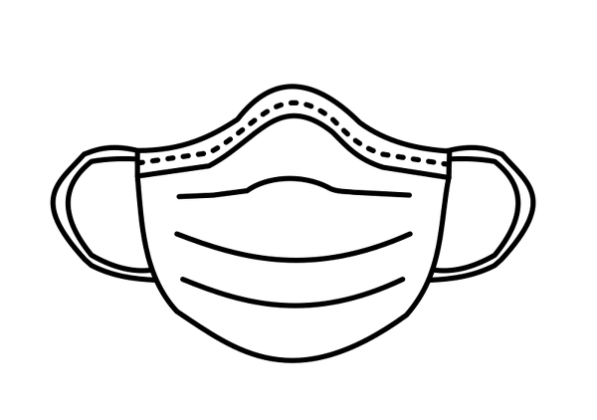
 |  Yes, fully vaccinated |  | No Quarantine (without symptoms) for inside class, work, or activities
 | Yes, both positive case and contact wearing a mask |  | No Quarantine (without symptoms) for inside class, work, or activities
 |   Not fully vaccinated  Both wearing masks |  | No Quarantine (without symptoms) for inside class, work, or activities
 | Not fully vaccinated  One has a mask  One not masking |  |  | Both Quarantine
 | Not fully vaccinated  Both not masking |  |  |  | Both Quarantine
 | Any positive case,  vaccinated or not |  |  |  | Quarantine

VACCINATIONS

Vaccination is currently the leading public health prevention strategy to end the COVID-19 pandemic. Promoting vaccination can help schools safely maintain in-person learning as well as extracurricular activities and sports. The CDC indicates, “Schools can promote vaccinations among teachers, staff, families, and eligible students by providing information about COVID-19 vaccination, encouraging vaccine trust and confidence, and establishing supportive policies and practices that make getting vaccinated as easy and convenient as possible.”
Missouri expects LEA’s to work with the local public health agency or other state enrolled vaccinators to offer vaccinations to eligible staff and students.

MPS officials are working with the Saline County Health Department and Fitzgibbon Hospital to organize future vaccination clinics.

TEST TO STAY and OTHER OPTIONS

The MO DESE has given schools permission to use the “Test to Stay” option for close contacts to stay in school and participate in activities. In collaboration with the Saline Count Health Department, MPS has deemed that this option is not endorsed by the CDC. Since The Safe Return to School Plan is based on CDC guidance, the Test to Stay option cannot endorsed at the local level. Therefore, MPS (along with the rest of the NCMC districts) does not recognize this option. Additionally, MPS does not recognize at-home test results for early return to school after a close contact.

CONTACT TRACING

Marshall Public Schools cooperates with the SCHD to contact those individuals who display symptoms of COVID or have been a close contact of an individual who has tested positive for the virus. A full-time MPS nurse has been assigned as the district point of contact to receive and share information with the Saline County Health Department.
MPS nurses will only contact parents when a student has been in contact with a classroom positive and it is necessary for them to be sent home immediately. The health department will be given the names and quarantine dates of the students who were required to quarantine. In some circumstances, school officials are notified of a quarantine from parents or other healthcare providers. This information will be verified with the health department. Building nurses assist the SCHD or the MPS point of contact nurse to communicate with students and families.
We will train one staff member in each building to serve as the internal contact tracer who will investigate which persons were within 3 feet for 15 minutes or more in a 24-hour period of a person who tested positive for COVID – 19. The building principal will use seating charts to determine what student(s) is a close contact. The student(s) identified will be sent to the nurse’s office. The principal will then contact parents to inform them that their student is a close contact of a positive case and to expect instructions from the SCHD. They are asked to come to school to pick up their student and gather belongings. The outcome of these investigations will be shared with SCHD personnel who will determine the student’s status and the length of the quarantine.

When informed of students who are considered close contacts, parents or guardians are contacted and this script is followed:

Hello! This is _____________ (your name) from __________________ (school)

I have a statement to read on behalf of the administration of Marshall Public Schools.
We have been informed that your child has been exposed to an individual that tested positive for COVID. The Saline County Health Department will be in contact with you in the next 24 hours and discuss quarantine dates. They will also answer any questions you might have. Thank you for your understanding.

Other points
- If your child develops symptoms, you need to contact the Saline County Health Department
- If your student needs a device delivered to your home, please let us know.

DIAGNOSTIC TESTING/SCREENING

Marshall Public Schools cooperates with the Saline County Health Department to contact those individuals who display symptoms of COVID or have been a close contact of an individual who has tested positive for the virus. The school district, however, does not test or screen students or employees for the virus.

(This plan will be evaluated every 30 days [or sooner] by MPS Board of Education and Administration,
then revised if necessary.)

Present:

October 21, 2020 Minutes
Introductions
roup overview and scope - Bryon
- This group is comprised of a volunteer cross section of MPS staff so staff concerns, and input can be garnered for suggestions to improve the R2L plan from a daily working standpoint. Advisement is also being sought in relation to health field expertise from Fitzgibbon representative(s) and SCHD staff to inform the team on best practices, trends and updated information regarding covid responses needed and other illnesses present in the community.
- Please be respectful of the group and the processes of group work. Disagreements are inevitable in group work, not all things will be covered or reached through discussion and everyone’s thoughts are valid and valued.
REMINDER: This is a working group and information should not be conveyed or shared until released into the newest version of the R2L plan to the district and community.
Updates to R2L plan and questions - Dr. Maher
Updates from SCHD and Fitzgibbon – Tara and Dr. Haug
Essential workers – Bryon
- SCHD at this time has recommended that all staff not be classified as essential – has that thought changed?
- Classified staff and teachers still have questions regarding how this will effect employment, time covered through illness and other questions.
- MPS staff are currently not classified essential workers and do not fall under those return to work criteria.
Group Discussion and comments
Next meeting date (2nd week of month unless needed prior)

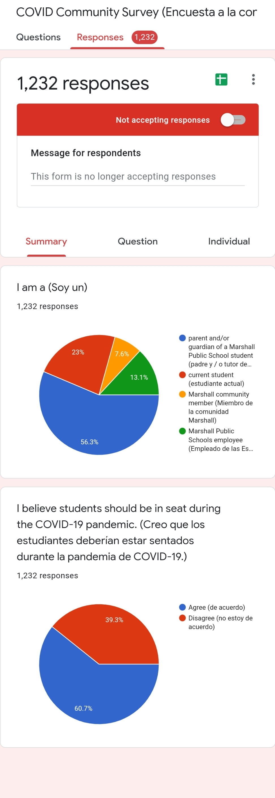

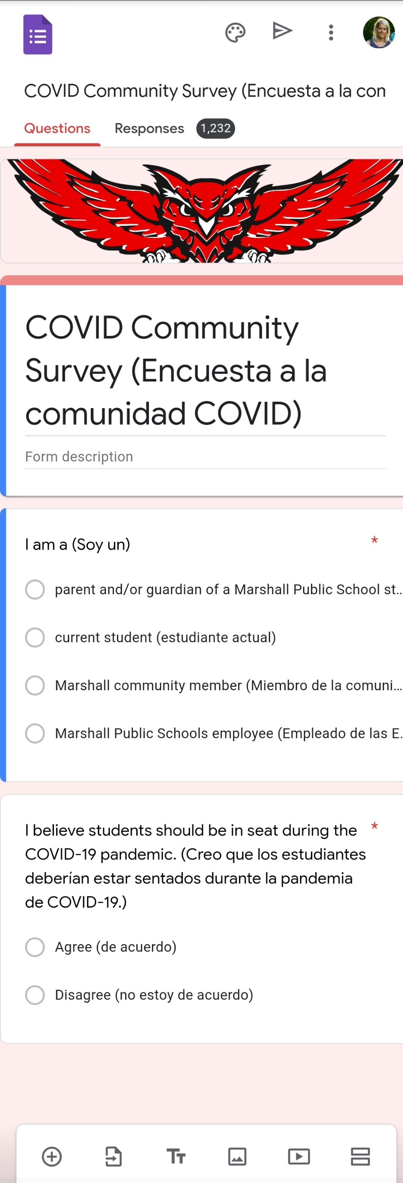

From the collective information gathered and data collected, the entries below are based on the requests and expectations from the community of Marshall for the improvement of the learning experience for all students.

