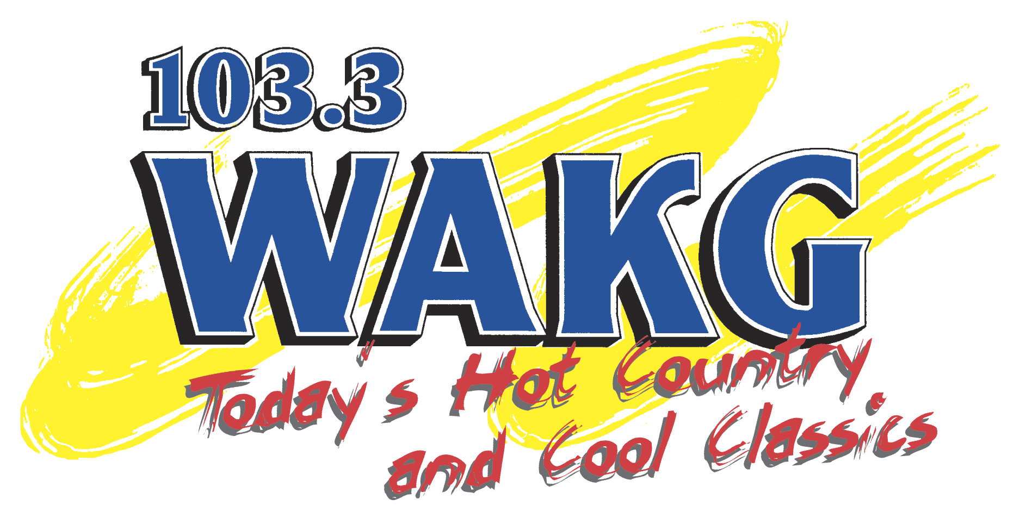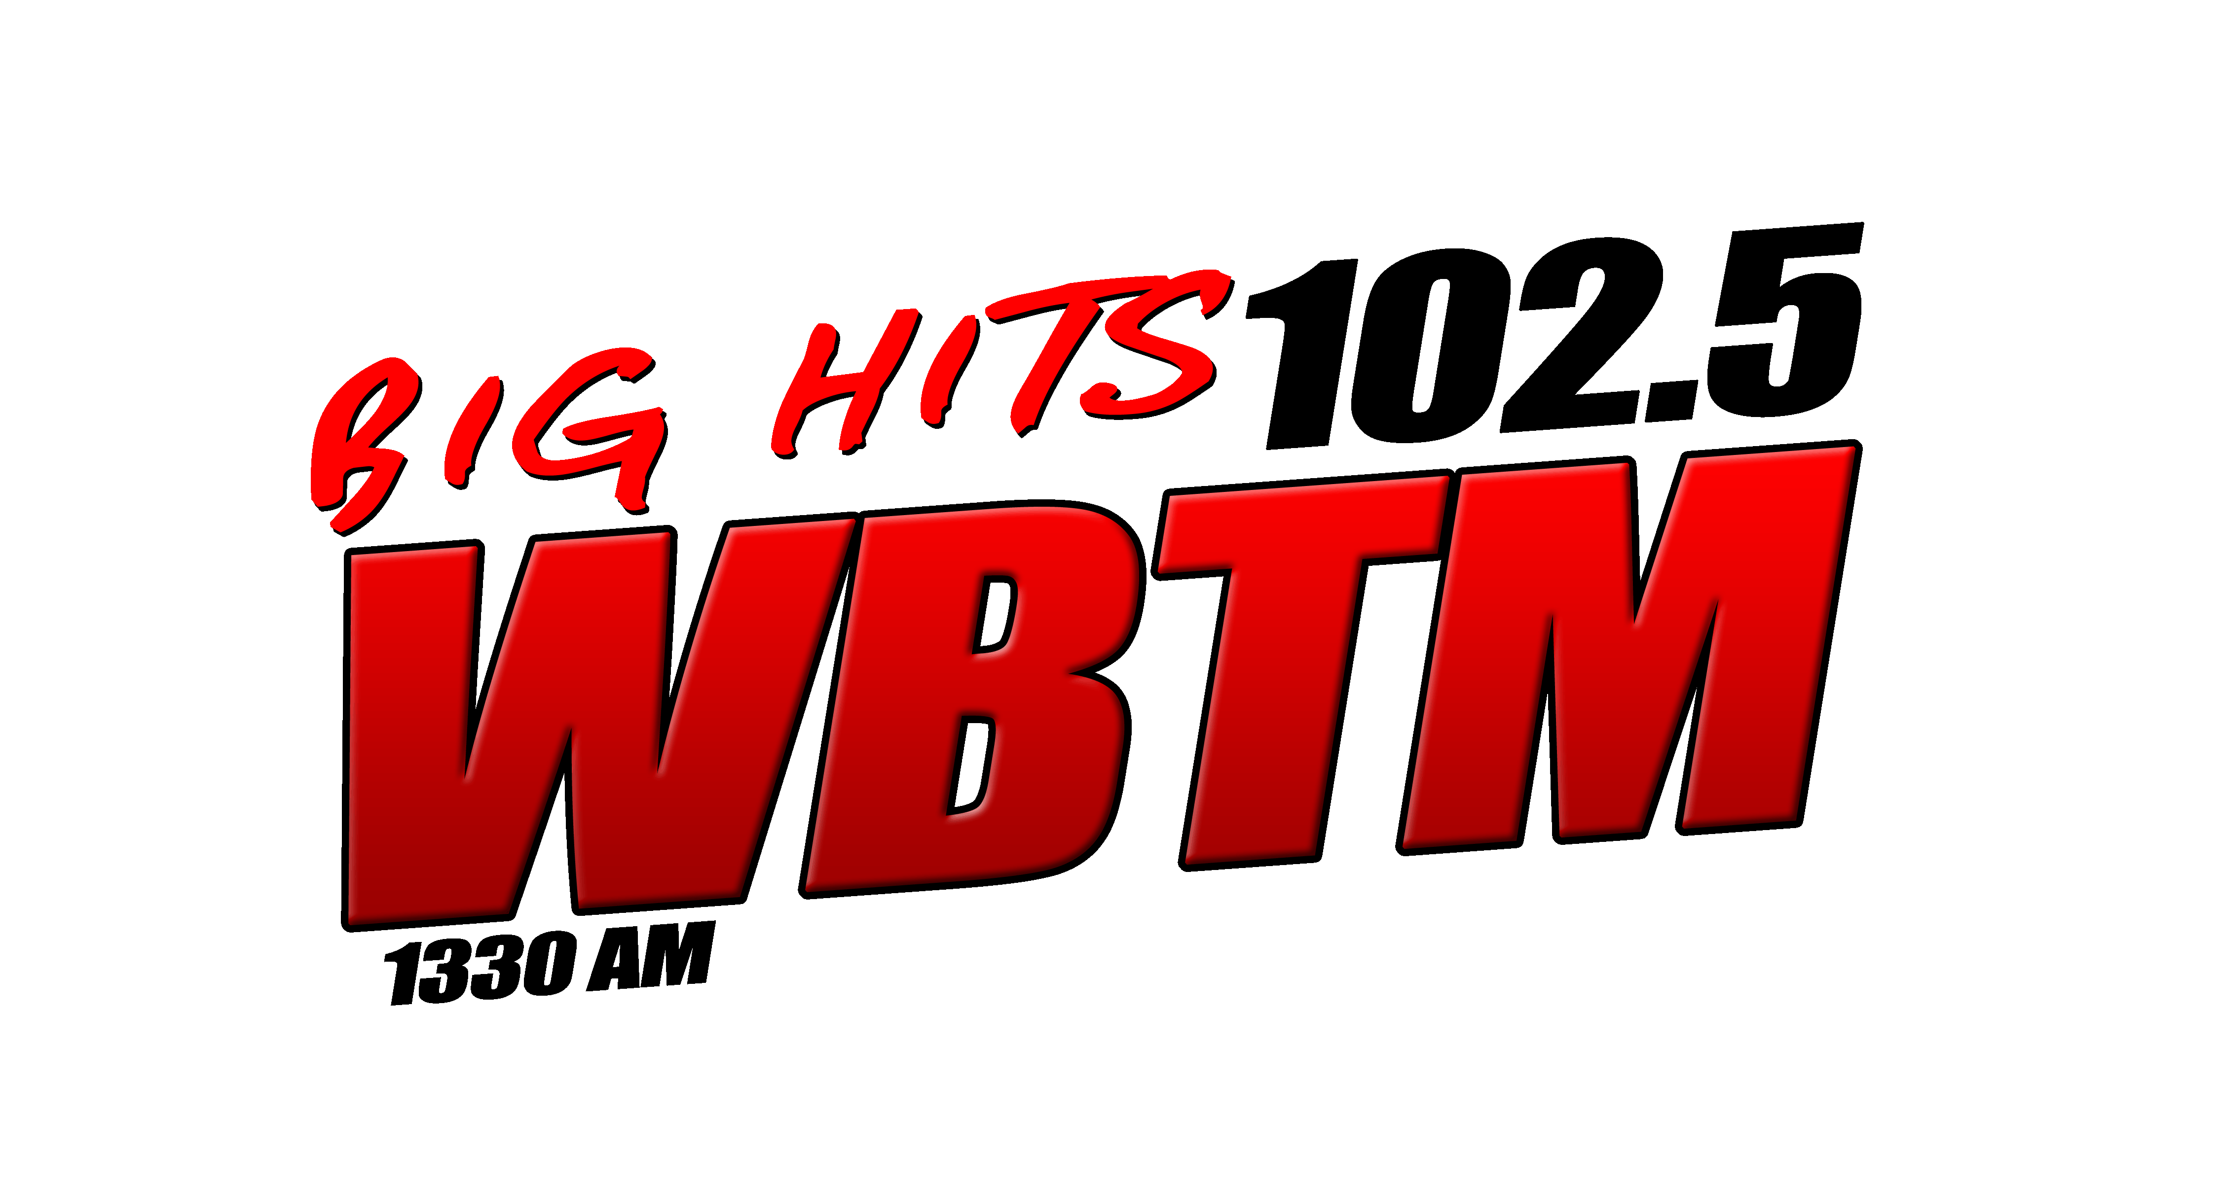

Piedmont Broadcasting Corporation
Media Kit
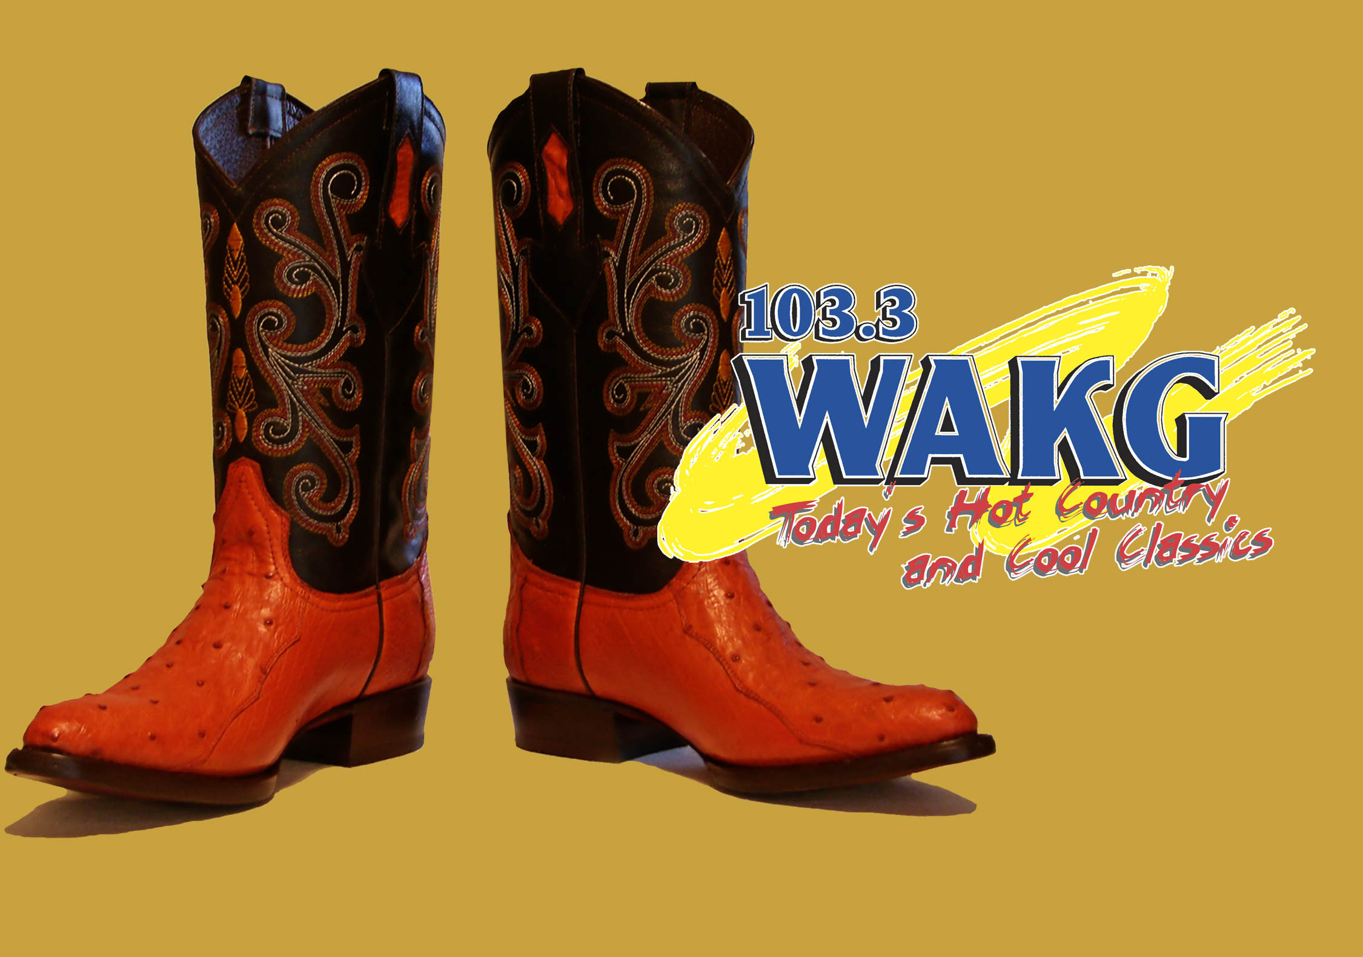
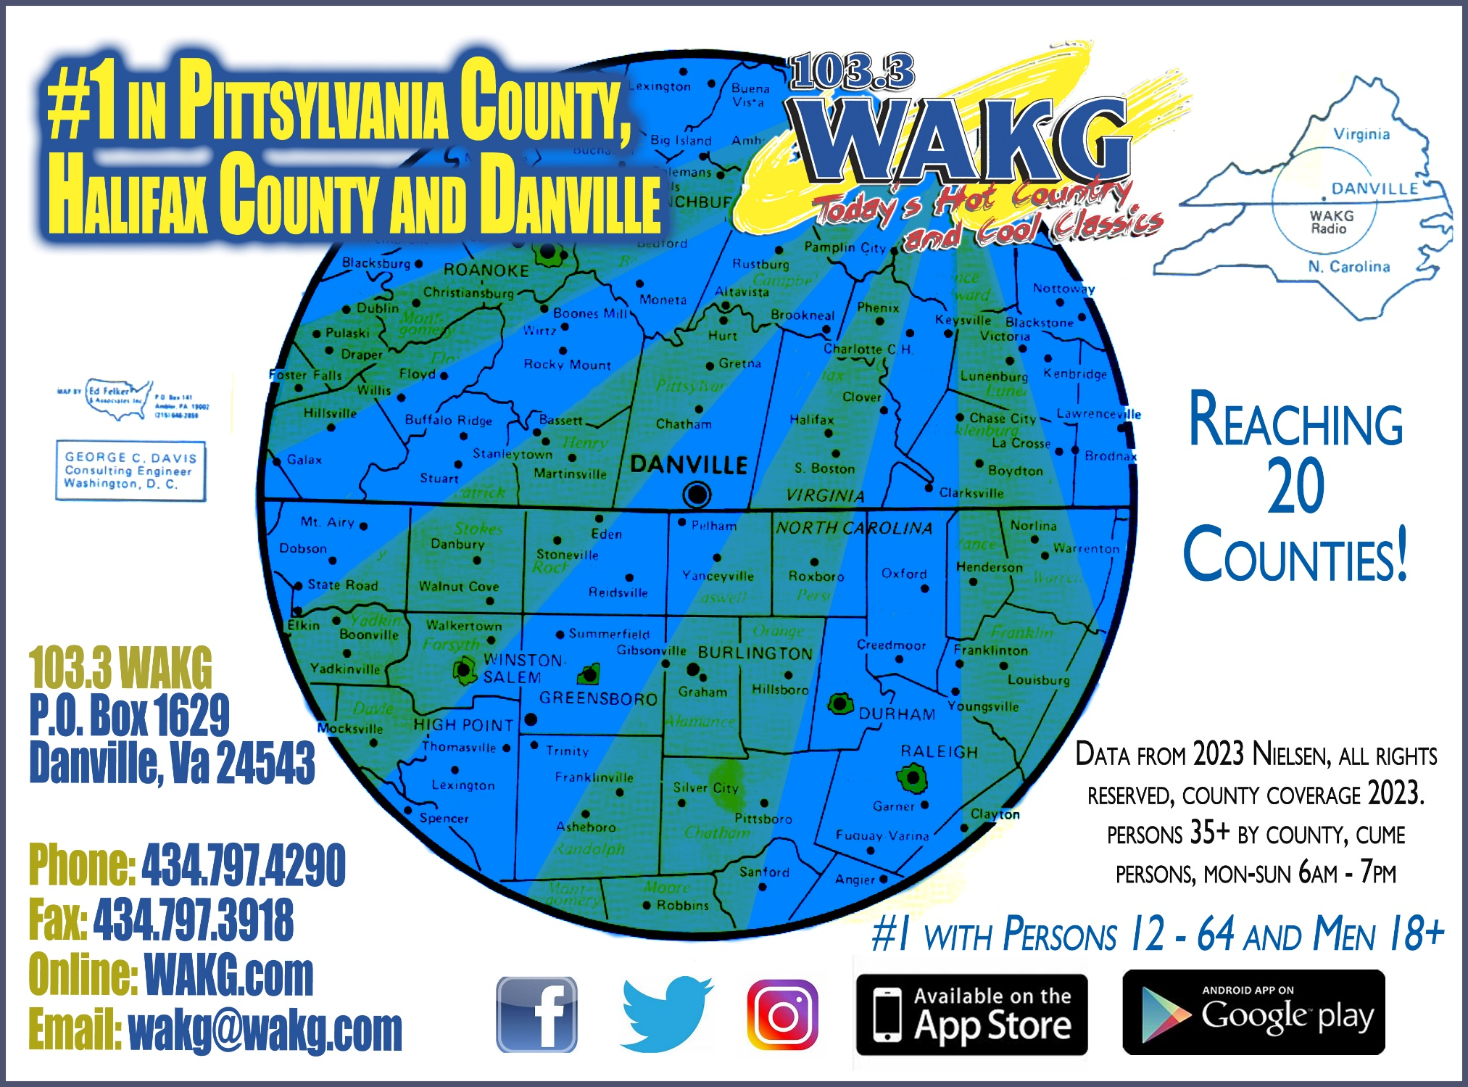

Demographics
Who is a WAKG Listener?

Power: 100,000 Watts
Coverage: 20 counties in Virginia and North Carolina
Target Demo: 18-54 Male/Female
Total Cume: 79,400
Who We Play

Jason Aldean
Carrie Underwood
Eric Church
Miranda Lambert
Luke Bryan
Maren Morris

Luke Combs
Morgan Wallen
Chris Stapleton
Dan + Shay
Carly Pearce
Lainey Wilson

PLUS Speciality Weekend Programming
Saturday Night Cool Classics zMax Racin’ Country RiseUp Country
CT 40 with Fitz

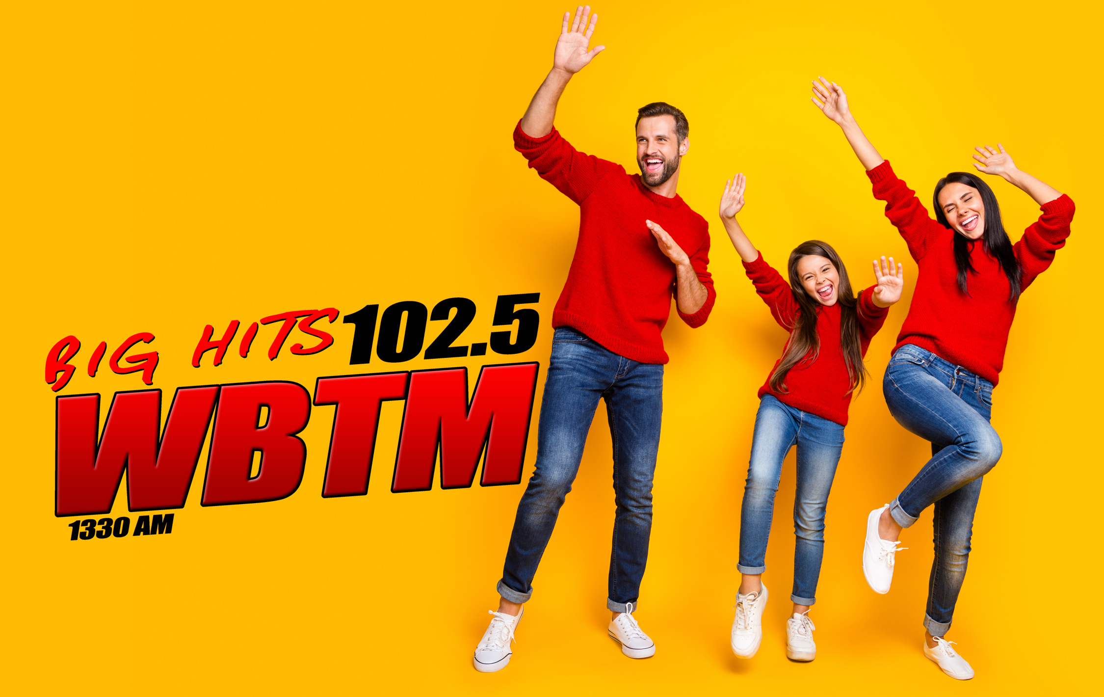
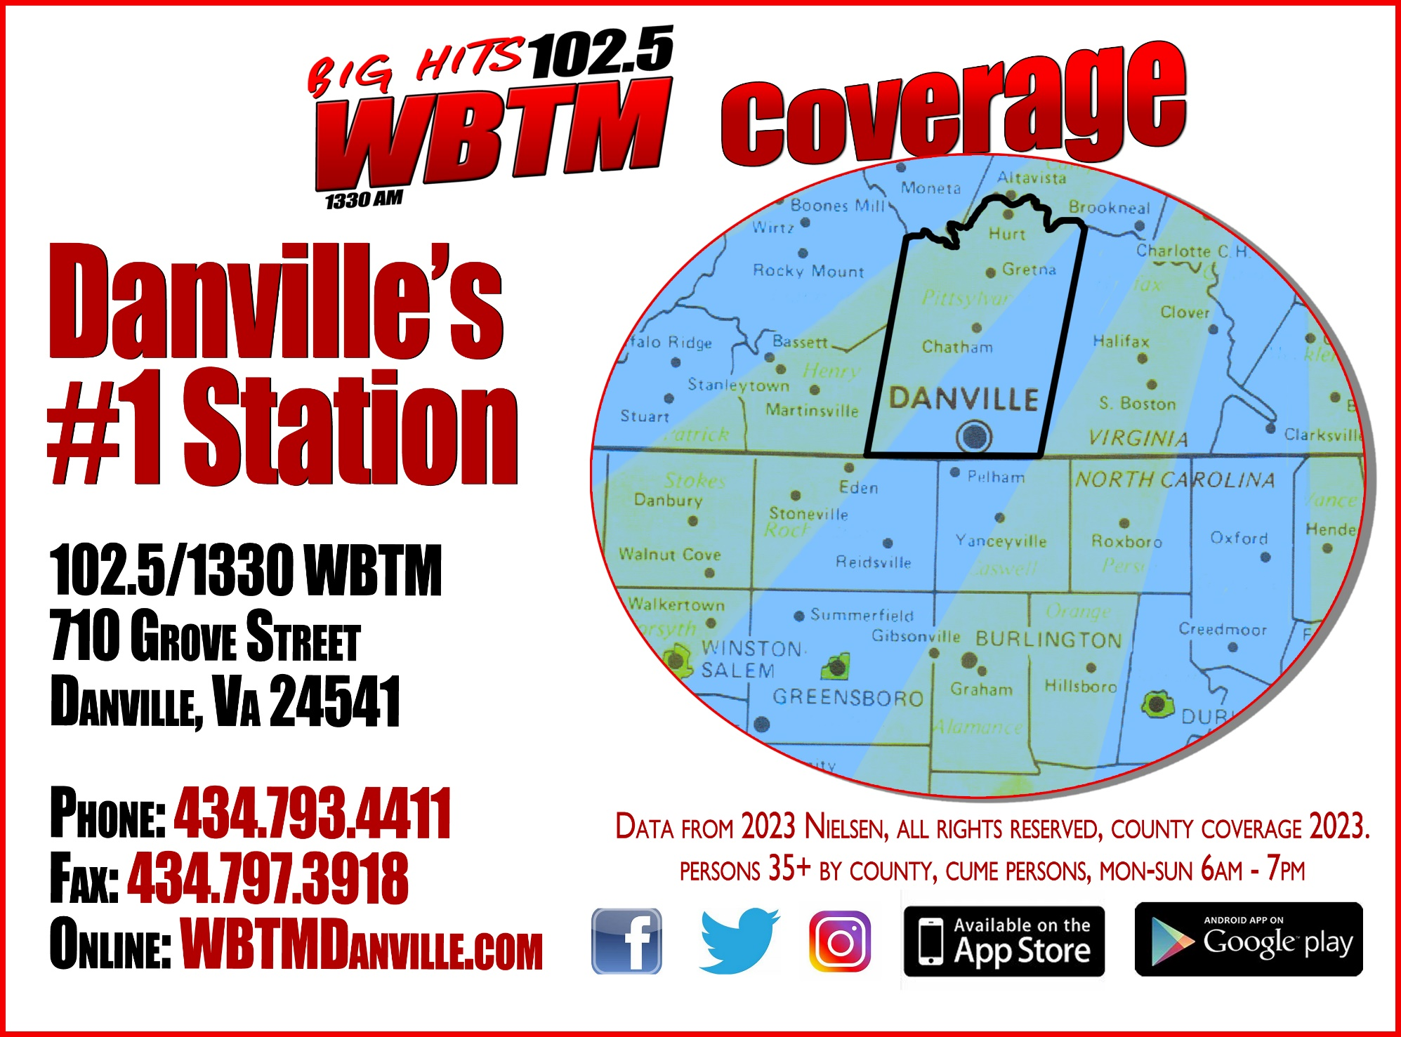

Demographics
Who is a WBTM Listener?

Power: AM Station with an FM Transmitter
Coverage: AM covers Danville, Pittsylvania County and Caswell County with an FM Transmitter that mainly covers the Danville area
Target Demo: 35 + Female / 50 + Male
Who We Play

Adele
Bruno Mars
Whitney Houston
Bruce Springsteen
Demi Lovato
Imagine Dragons
Maroon 5
Celine Dion
Ed Sheeran
Journey
John Legend
Mariah Carey

PLUS Speciality Weekend Programming
Retro Hits (50s, 60s, 70s) Throwback Nation (80s and 90s) Sunday Special Blend (Easy Listening)
Sunday Night Beach and Motown
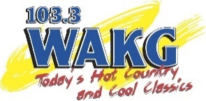Broadcasting Tools

On-Air

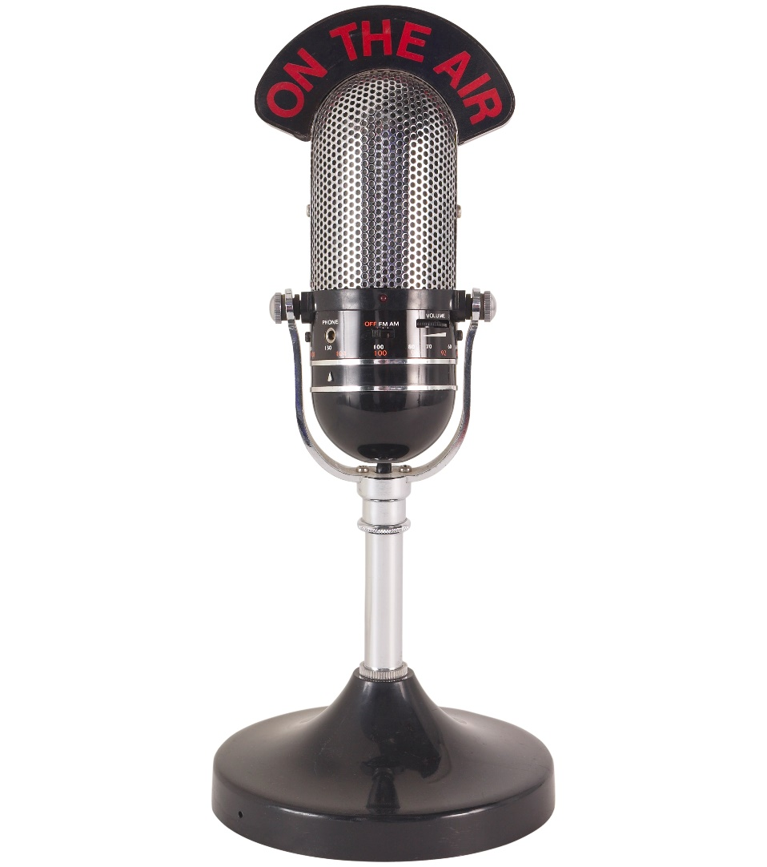
  - Personalities who drive traffic to your business through promotional and feature-content partnerships
            - Sponsor one of our great giveaways
    - Let us highlight and brand your business through a feature or specialty show that embeds you in our programming

  - Award-Winning Recorded and Produced Commercials
    - Our experienced Copy Department can bring your ideas to life and make your services and products stand out.
    - We utilize a wide variety of sound effects and music beds to make your commercial pop!
    - Great selection of voiceover talent to make your commercials stand out and create “theater of the mind”
    - We offer :05, :15, :30 and :60 Commercials

  - Live Remote Broadcasts
    - Host one of our personalities for two to four hours for a live broadcast from your location.
    - You also have the option to be a broadcast sponsor (we’ve had this be for non-profit or community-oriented events/fundraisers)
Broadcasting Tools
Online

  - WAKG.com and WBTMDanville.com
    - We’re mobile-friendly – access us on ANY device

    - We’re app-driven
      - All of our website content displays directly on our FREE app

    - Our websites feature local, national and world news updates
      - This is a service we provide without membership or cost to the public
        - Our articles are shared on our Facebook and Twitter feeds

    - Giveaways
      - We’re able to have a variety of contests on our websites/apps

    - Country Club / Listener Club
      - Listeners sign up to receive emails about promotions, events and more!
Broadcasting Tools
Social Media
Stats as of August 1st, 2023

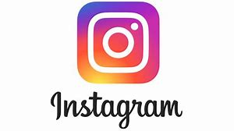 | (Formerly Twitter)
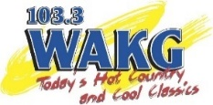  2,299 Followers  622 Followers | 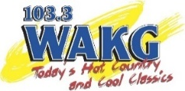  1,516 Followers  918 Followers | 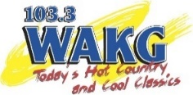  23,000 + Likes  42, 000 + Followers  5,100 + Likes  6,500 + Followers | 1,024 Likes  474 Followers

Our local competitors aren’t on Instagram, Tik Tok or Twitter.

Broadcasting Tools
Social Media Approximate Regional Breakdown
Stats as of August 1st, 2023

Approximate Regional Breakdown  - 4596 Danville Followers  - 1530 Pittsylvania Co Followers  - 1041 Rockingham Co Followers  - 789 Caswell Co Followers  - 756 Person Co Followers  - 1081 Henry Co Followers  - 483 Gilford Co Followers  - 1580 Halifax Co Followers | Approximate Regional Breakdown  - 2258 Danville Followers  - 600 Pittsylvania Co Followers  - 185 Caswell Co Followers  - 105 Henry Co Followers  - 185 Rockingham/Person/Guilford Co Followers
68% Female  32% Male | 73% Female  27% Male
Local, Award-Winning News

On-Air Monday – Fridays: 6am, 6:30am, 6:55am, 7:30am, 8am and 8:30am

Continuous Online Updates on Social Media and with Push Notification Updates on the Free WAKG and WBTM Apps

WAKG.com Average Time: 1 minute per article WBTMDanville.com Average Time: 50 seconds

We Love Our Community
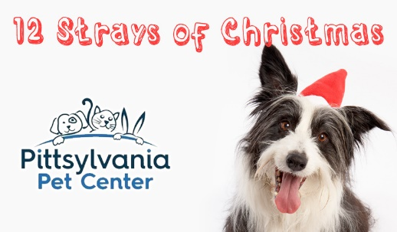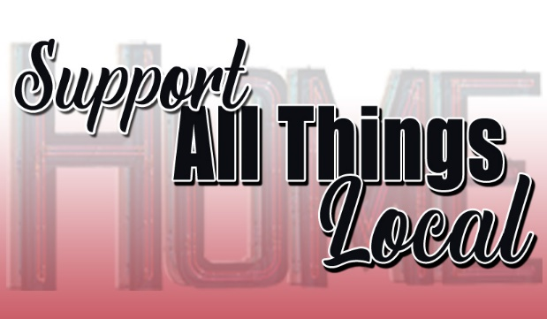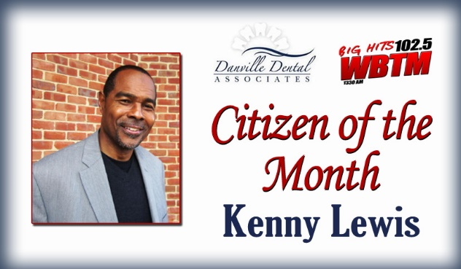
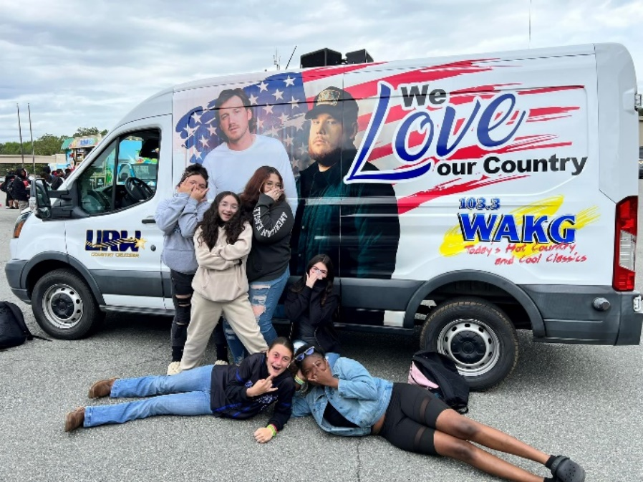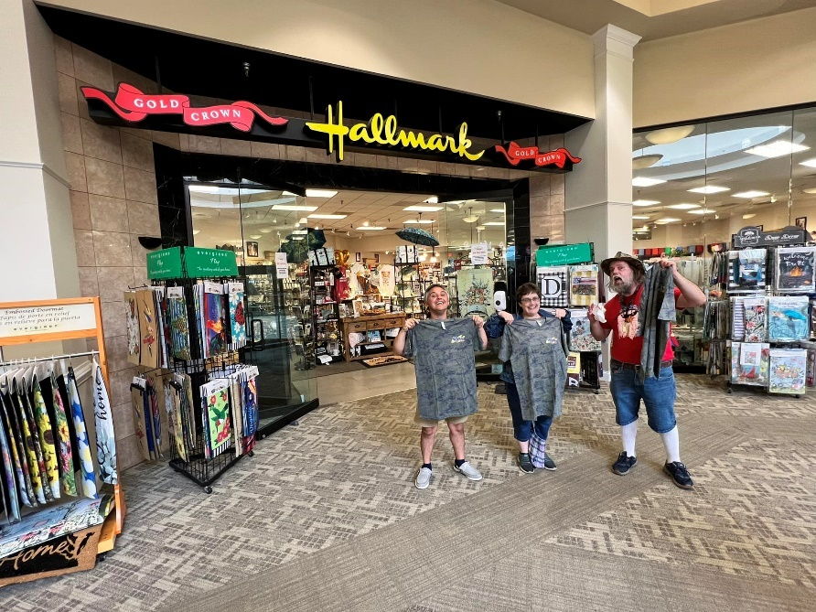

We Love Giving Away Prizes

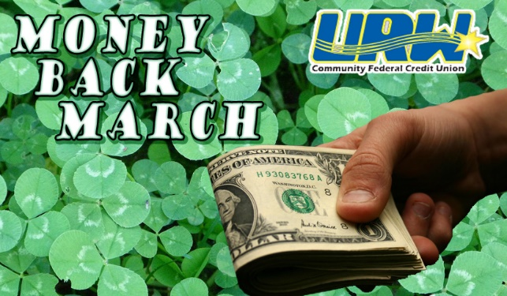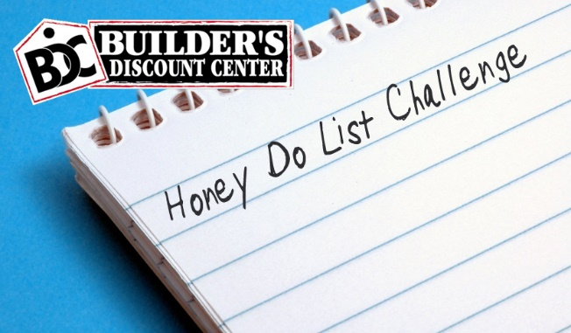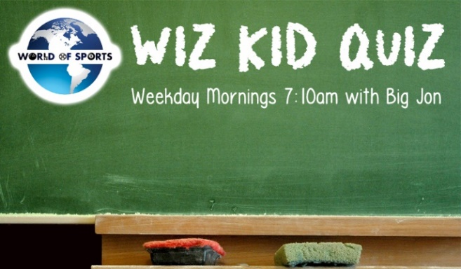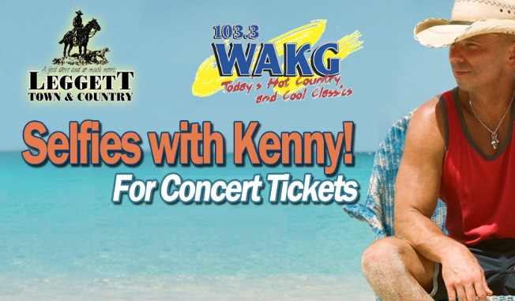
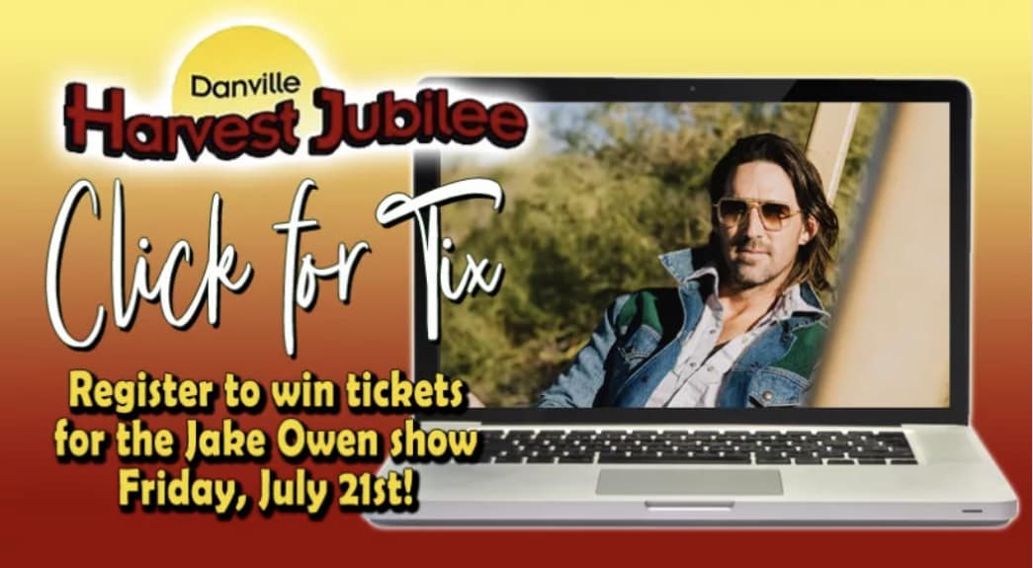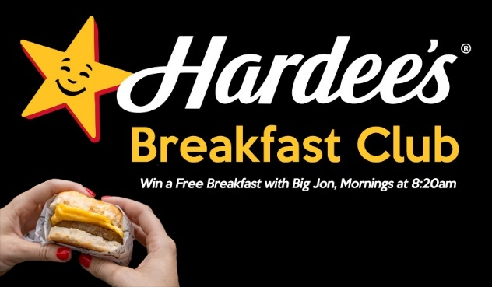

We’re Honored to be Recognized for Our Work
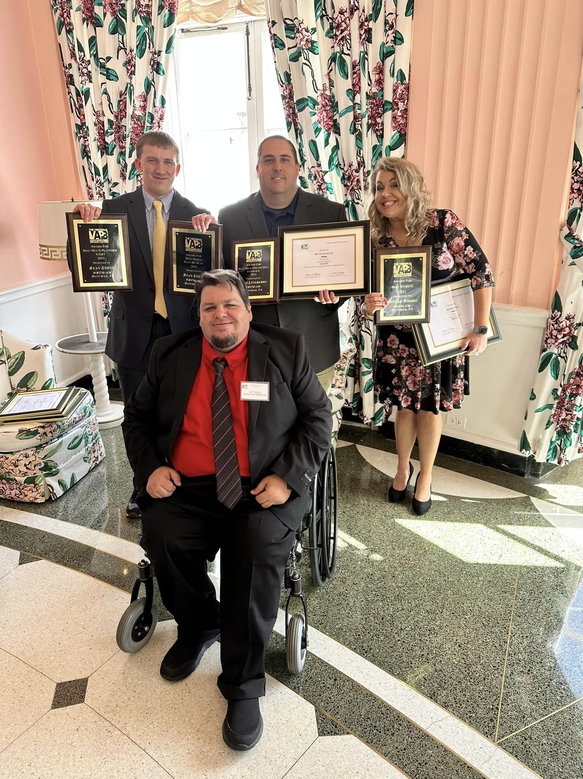

- Best Spot News
- Best Continuing News
- Outstanding Sports Operation of the Virginias
- Best Light News Feature
- Best serious Feature
- Best Sports Play-by-Play
- Best Reporter
- Best News Promo
- Best Station Promo
- Best Newscast
- Outstanding News Operation of the Virginias
- Robert Gallimore Distinguished Service Award

We’re Honored to be Recognized for Our Work

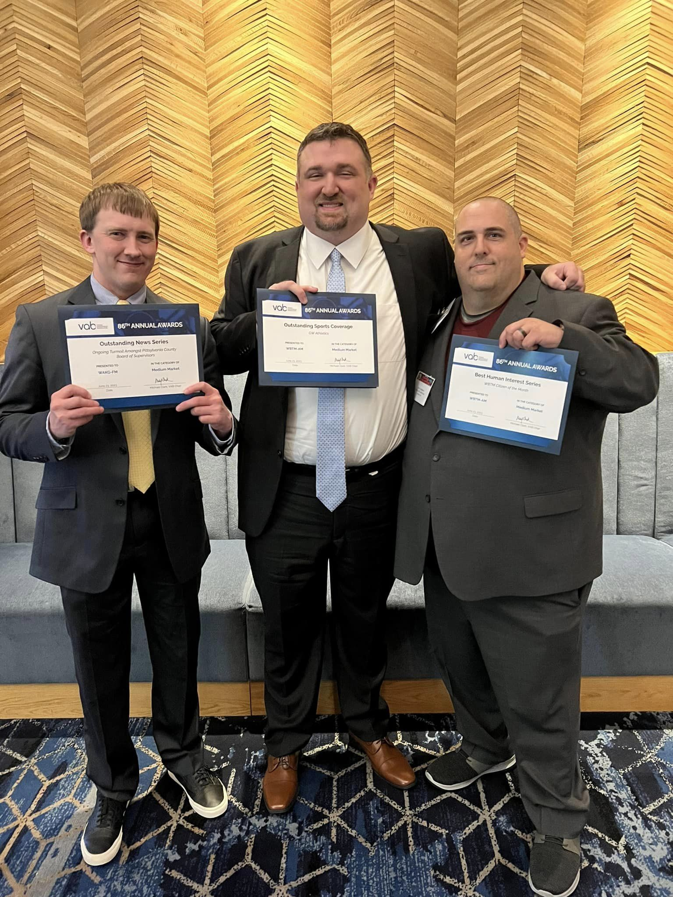

- 2020 Award for Creative Excellence
- Best Station Promo/Contest
- Best Human-Interest Series
- Outstanding News Series

