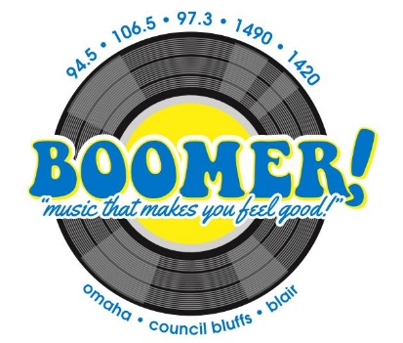

Sponsor Jack Swanda’s Sit IN
on Boomer Radio!

You are invited to join Boomer Radio’s live Sit IN broadcast of Omaha’s Who’s Who with Jack Swanda and receive live SHOUT OUT ‘thank you’s’ for your sponsorship!
Two Sit In’s per month = $150 and receive 1 :30 second prerecorded spot.. PLUS Receive a minimum of 8 business name sponsor thanks on the Boomer Radio Network promoting Jack’s Sit In! PLUS a minimum of 2 ‘Thank you for your sponsorship’ mentions during the broadcast!
Just $150 per month
___________________________________ ____________________
Signature Date

___________________________________ ____________________
Company Date
