Boomer 2021 Classic Car Calendar
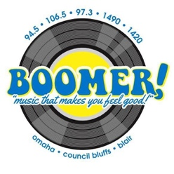
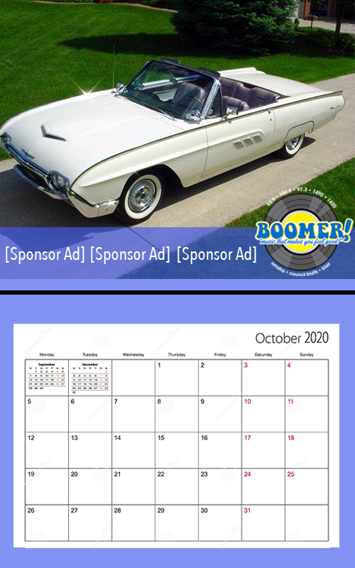

Boomer Radio is tapping into our passion for classic rides by
producing our Custom Classic Car Calendar for 2021!
Your business can be a monthly sponsor!

LIMIT 3 SPONSORS
PER MONTH!

Your business will receive:
- Prominent calendar ad placement on chosen month
- Only three sponsors per calendar month
- *50 calendars for distribution at your locations!
- Inclusion in 100 station promos per month!
- A bank of 30 :30 second commercials per month!
- Monthly Facebook Post in 2021!
1 month sponsorship $900/mo
6 month sponsorship $800/mo
12 month sponsorship $700/mo

__________________________________ ________________________________
Accepted By Boomer Representative
__________________________________ ________________________________
Business Date

*Additional Calendars available for $2 each

