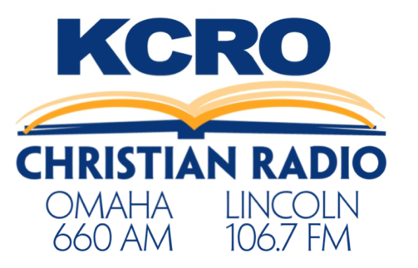

Dave Ramsey Sponsorship
Dave Ramsey show airs on KCRO M-F 2PM – 4PM
3 Sponsorship Levels:
- Presenting Sponsor
- Opening Billboard
- 2 :30 commercials per show M-F
- Your logo prominent on the KCRO Website AD
- Your logo prominent on a digital Billboard for 3 months
Monthly Investment: $1,500 net
- Gold Sponsor
- 2 :30 commercials per show M-F
- Your logo on the KCRO Website AD
- Your logo on a digital Billboard for 3 months
Monthly Investment: $1,000 net
- Silver Sponsor
- 1 :30 commercial daily M-F
Monthly Investment: $500 net

