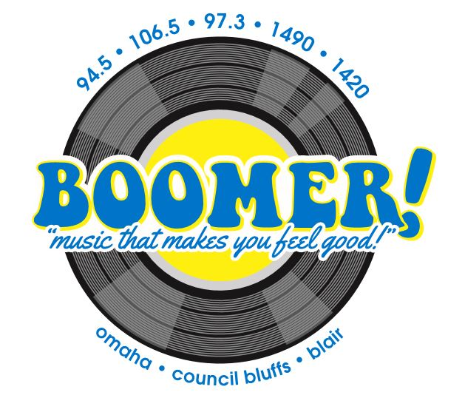

Sponsor Full Album Friday’s with Jessica Dol!
What you’ll receive:
- 10 liners a week
- Opening Billboard
- 2 :30 commercials during the Full Album Friday Feature
- Web Site Ad
- Weekly Contest*
*The contest: Jessica Dol will ask a trivia question about the album being featured on Full Album Friday. The first caller to give the correct answer wins.
Winner Receives: One $25 or $50 gift certificate to your business

Your Investment:
$500 per month plus prizes
Provide (4) $25 or $50 gift cards to your business
*An investment for 12 months or more will get a FREE quarterly promotion!

______________________________________________ ____________________________
Signature Date

_________________________________________________
Business Name

