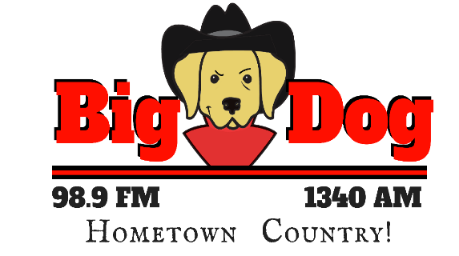
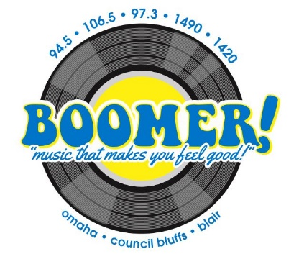
THE GREAT OUTDOOR
RADIO SHOW
with Greg Wagner
ON BOOMER RADIO and
BIG DOG HOMETOWN COUNTRY in Fremont!
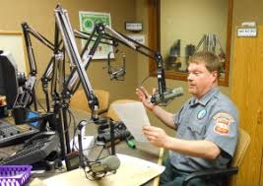
TITLE SPONSORSHIP
Client Receives:
Opening and Closing Billboards as TITLE SPONSOR
4 :30 Commercials inside the show
Inclusion in 25 live and recorded weekly promos
60 :30 commercials per month on BOOMER and BIG DOG!
60 Matching commercial schedule on stream!
Prominent inclusion in ad on myboomerradio.com
Podcast posted online!
BONUS!!
One live remote broadcast at client location ($1200 value!)

Investment: $2500 per month

__________________________________________________ _________________________
Signature

_________________________________________________________ __________________________
Business Date

_____________________________________________________________________________________
Station Approval

Based on 12-month agreement. Walnut radio to produce all commercials at no charge. Remote date based on availability.

