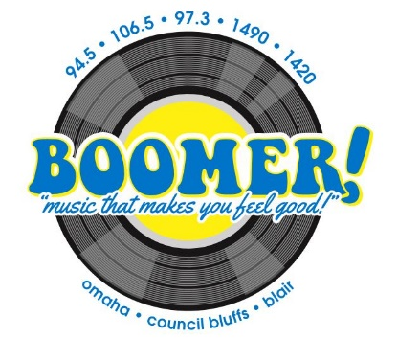
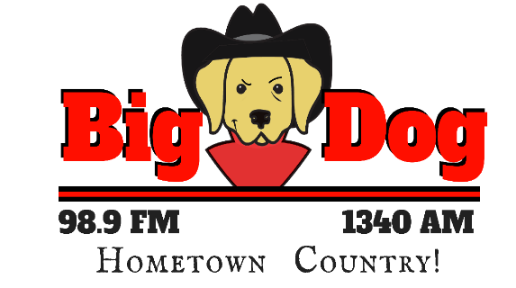
SPONSOR
THE GREAT OUTDOOR
RADIO SHOW
With Greg Wagner
ON BOOMER RADIO and
BIG DOG HOMETOWN COUNTRY in Fremont!
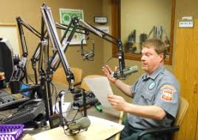
Saturday Mornings 9a-10a
Two levels of sponsorship are available
Based on 12-month agreement:
The Bait:
- Receive mentions in an opening and closing billboard
- Inclusion in 25 promos a week
- Two :30’s in each show
- Minimum of 1 live mention in show
Investment: $600/month

The Big Game:
- Receive mentions in an opening and closing billboard
- Inclusion in 25 promos a week
- Two :30’s in each show
- Minimum of 1 live mention in show
- 30 :30’s a month on both stations!
Investment: $1400/month

__________________________________________________ _________________________
Signature

_________________________________________________________ __________________________
Business Date

____________________________________________________________________________________
Sponsorship Chosen

