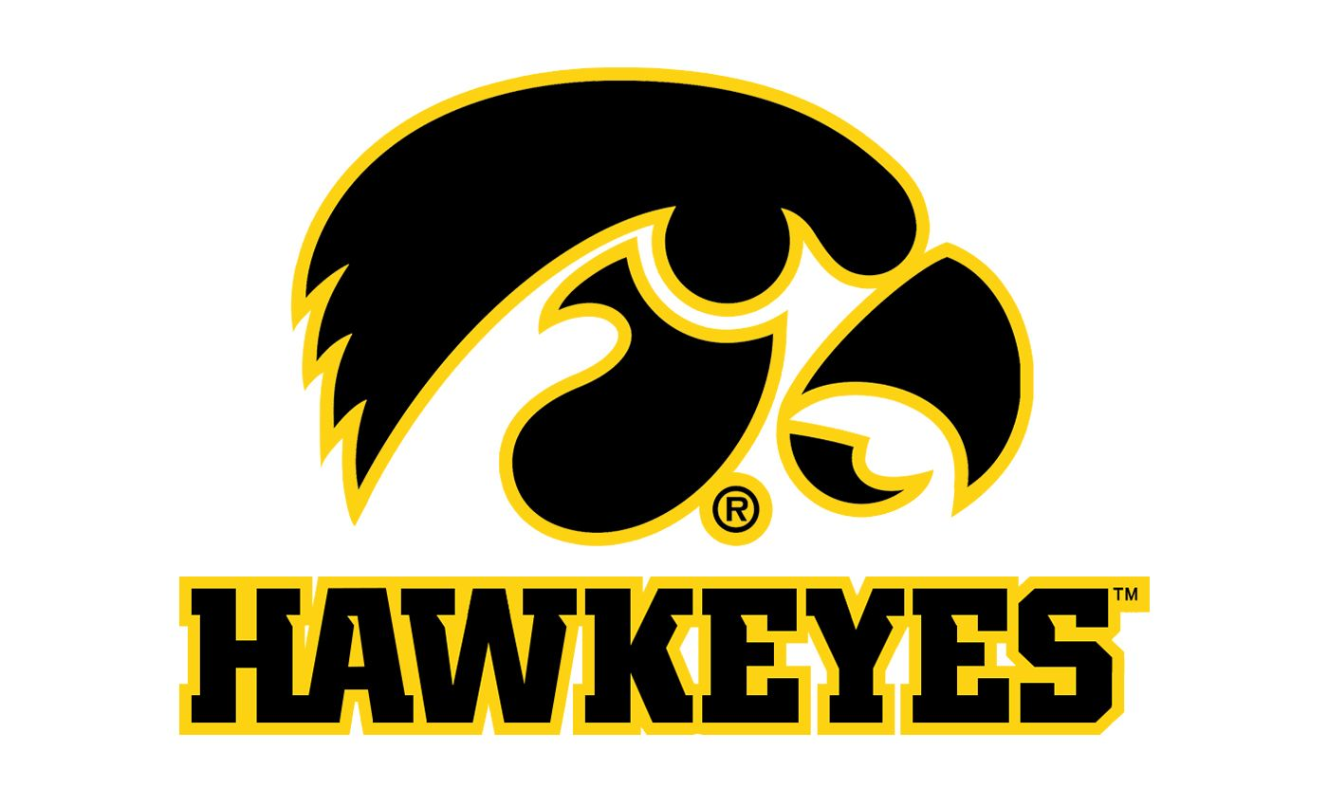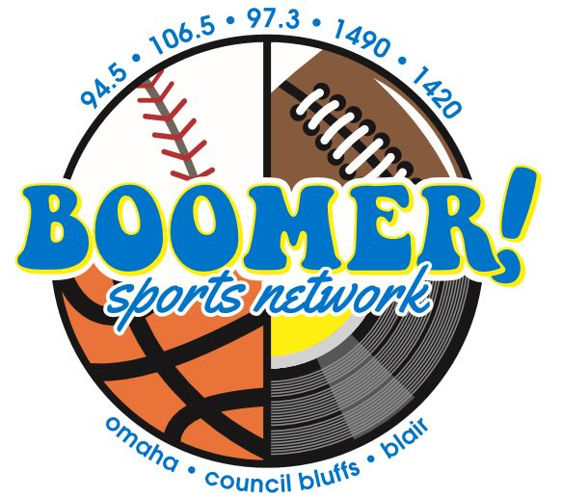

The Hawkeyes on Boomer!

106.5 FM & 1490 AM Council Bluffs/Omaha

Sponsorship Package
As a Boomer/Hawkeyes sponsor you will receive:
- 6 :30s in each regular season football and basketball game broadcast
- Inclusion in a minimum of 20 promotional announcements each week of the season.
- Hawkeye sponsor Logo on myboomerradio.com
- Monthly Facebook post to our 6,000 friends!
- That’s 192 in-game commercials!

Optional:
- A bank of 30 :30 commercial announcements per month on the Boomer Network (6a-8p M-Sun)

Investment: $450 per month Add on Option $ 400
Billed monthly Oct 2020-March 2021

Yes, count me in!
Business Name: _________________ By: ______________Date_____

