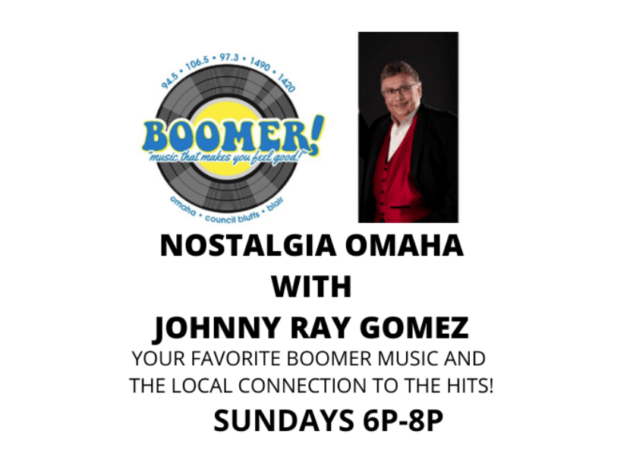
SPONSORSHIP PACKAGE!
Client receives:
Inclusion in a minimum of 25 recorded promos weekly on Boomer!
One :30 commercial in the program
Live mention during broadcast
Logo on show page on myboomerradio.com
Promos and commercials included in web stream and podcast!
Live broadcast of show at your location discount option: $600
Investment: $150 per week

Client___________________________
By______________________________
Boomer Rep______________________

