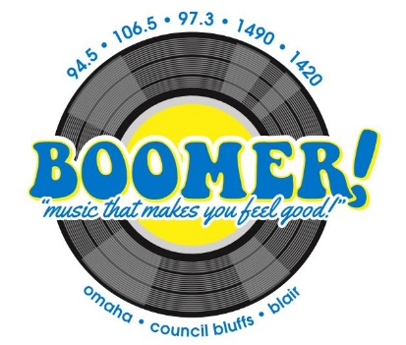

2-hour On Location
Live Broadcast
Let Boomer Radio make your event special with a live, on location broadcast. We bring the fun, including our Air Personalities, Prizes and Games!

The Boomer Live Broadcast package includes:
- 2-hour remote with 4 live :60 cut-ins per hour
- Boomer Mobile on location
- 25 live/recorded promotional announcements for 5 days leading up to the remote
- Listing on community calendar on myboomerradio.com

Your Investment: $750 + $150 talent fee

Remote Date & Time: _____________________________________ Subject to availability

Signature: _________________________________ Date: _______________
Business Name: ____________________________________________________

